FOSS4G 2007
FREE AND OPEN SOURCE SOFTWARE FOR GEOSPATIAL 2007



Volunteer’s Handbook

Table of Contents
Letter to Volunteers 3
2.0 Volunteer Duties 4
3.0 Contacts 6
4.0 Victoria Conference Centre Diagram 7
5.0 Schedule: Sunday September 23 - AM 9
6.0 Schedule: Monday September 24 AM 11
6.1 Schedule: Monday September 24 PM 12
6.1 Schedule: Monday September 24 PM...continued 13
7.0 Schedule: Tuesday September 25 AM 14
7.1 Schedule: Tuesday September 25 PM 15
8.0 Schedule: Wednesday September 26 AM 16
8.1 Schedule: Wednesday September 26 PM 17
8.2 Schedule: Wednesday September 26 PM …continued 18
9.0 Schedule: Thursday September 27 AM 19
9.1 Schedule: Thursday September 27 PM 20
Appendix 1 Computer Setup Procedures 21
Appendix 2 Workshop and Lab computer check 23
Appendix 3 Classroom PC Internet Access 24

Letter to Volunteers

Volunteers,

On behalf of the FOSS4G 2007 Organizing Committee, I wish to thank each of you for supporting this great event. The 2007 Free and Open Source Software for Geospatial (FOSS4G) conference gathers developers and users of open source geospatial software from around the world to discuss new directions, exciting implementations, and growing business opportunities in the filed of open source geo-spatial software. FOSS4G is presented annually by the Open Source Geospatial Foundation (http://www.osgeo.org)



This instructions booklet outlines duties and responsibilities for volunteers. Schedules have been created with times and locations. Before your shift starts, please report to the FOSS4G2007 Conference Office for final instructions (Metchosin Room, Level two). Please come early to register so you can go directly to the FOSS4G2007 Conference Office.

With your help, the FOSS4G2007 will be a grand success.

Thanks for all the work.

Brian Low
Volunteer Coordinator
Committee Member FOSS4G 2007

2.0 Volunteer Duties
Position | Duties
Registration | - Liaise with Sea to Sky  - Assist in registration, and help desk  - Pass out information packages  - Answer questions about the conference  - Answer questions about Victoria  - Be Happy !!
Security @ Victoria Conference Centre | - Ensure that only registered delegates enter area  - Instruct those who are not registered to go to registration desk at Victoria Conference Centre Pre-Function 1a  - Keep area quiet during sessions  - Enforce no-smoking  - Insure no one exits area with conference hardware
Room Monitor | - Ensure lab / Workshop computers and presentation computer are Working (see check off list in Appendix 2)  - For Workshops check names off list  - Ensure that only registered delegates are in room  - Assist instructor(s) and presenter(s) / session chair  - Enforce no Web email on Workshop/Lab computers  - Enforce no peer2peer (ICQ,IRC,msn chat..) communications on Workshop/Lab computers  - Hand out evaluation forms for workshops & labs  - Collect evaluations forms from attendees and the instructor(s)  - Keep room and area quiet during sessions  - Enforce no-smoking  - Enforce no food or drinks (except water) in workshops/labs
Computer Assembler | - Assist in the moving of computers from palettes to Workshop / lab rooms  - Assist in the assembling of computers (see check list in Appendix 1)  - Test computers are working
Computer take-down | - Disassemble computers  - Assist in the moving of computers & monitors to palettes
Security @ Royal British Columbia Museum | - Liaise with Sea to Sky  - Insure only paid attendees with dinner tickets are allowed in to Museum and Imax  - Enforce no-smoking
Poster session coordinator | - Aid presenters in poster setup  - Ensure correct number of posters per board (4 maximum)

3.0 Contacts
If you need to contact any of the organizing committee members or the volunteer coordinator during the conference please go to the Conference Office room (Metchosin Room, Level 2) or the registration desk (Pre-Function 1A, Level 1) and contact the Sea to Sky representative. Sea to Sky will contact the committee members via radio and dispatch your message.

Situation | Contact method
Before the event | - Email: volunteers@foss4g2007.org
Computer setup issues (pre-event) | - Brian Low or Dave Patton - Committee Members
Workshop problems | - Dave Patton – Committee Member
During the event (not during your volunteer session) | - Go to Conference Office room (Metchosin Room, Level 2) or the registration desk (Pre-Function 1A, Level 1)
During the event (during your volunteer session) | - Contact committee members/Sea to Sky. They will be walking around. Contact any of them.
Critical medical/fire emergencies (during your volunteer session) | - In the event of an emergency, alert Victoria Conference Centre Client Services by dialing 1011 at the nearest house phone. A house phone is located in each room and common area. Clearly indicate your location, the nature of the emergency, and a first aid responder, fire or ambulance will be dispatched immediately.  - Yell in hallway  - Contact committee members/Sea to Sky. They will be walking around. Contact any of them.
Need assistance (during your volunteer session) | - Contact committee members/Sea to Sky. They will be walking around. Contact any of them.

4.0 Victoria Conference Centre Diagram

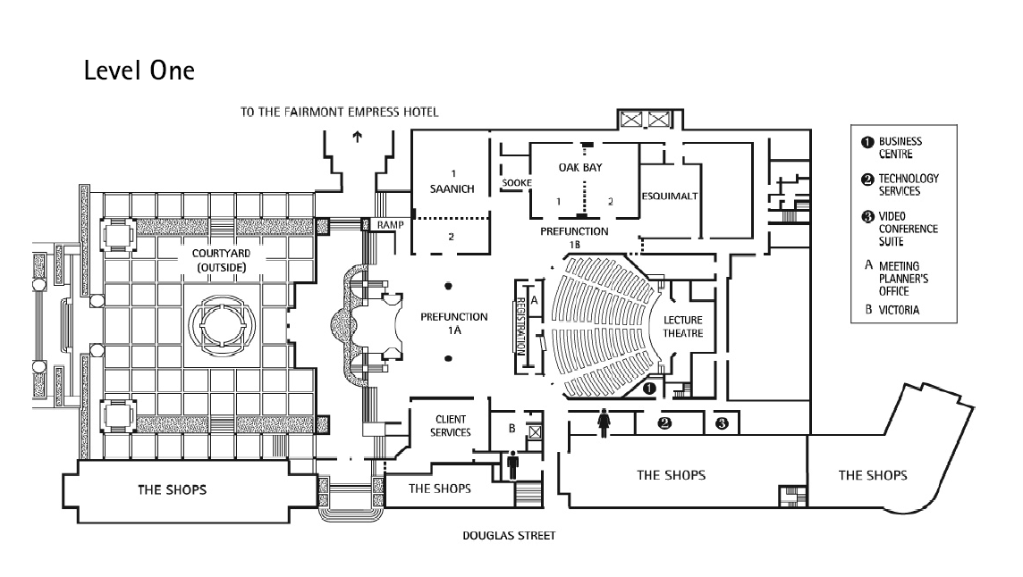

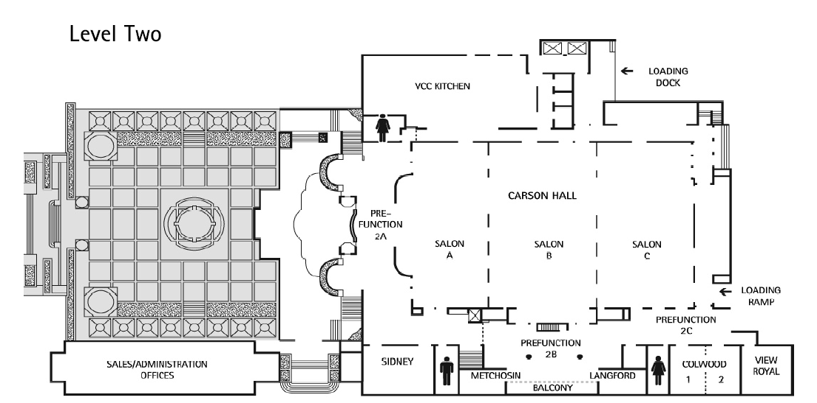

5.0 Schedule: Sunday September 23 - AM

Position | Location |  | Time |  | Volunteer
Computer Assembler #1 | Meet in Prefunction 1A / Saanich |  | 1130 – 1600 *or until completed |  | Darrin Charmley
Computer Assembler #2 | Meet in Prefunction 1A / Saanich |  | 1130 – 1600 *or until completed |  | Adam Quney
Computer Assembler #3 | Meet in Prefunction 1A / Saanich |  | 1130 – 1600 *or until completed |  | Graeme Leeming
Computer Assembler #4 | Meet in Prefunction 1A / Saanich |  | 1130 – 1600 *or until completed |  | Graham Davis
Computer Assembler #5 | Meet in Prefunction 1A / Saanich |  | 1130 – 1600 *or until completed |  | Amr Alam
Computer Assembler #6 | Meet in Prefunction 1A / Saanich |  | 1130 – 1600 *or until completed |  | Jeff Lounsbury
Position | Location | Time | Volunteer
Registration #1 | Pre-function 1A | 1400 – 1915 | Emily Gouge
Registration #2 | Pre-function 1A | 1400 – 1915 | Sascha Martens
Registration #3 | Pre-function 1A | 1400 – 1915 | Philip Kayal
Security #1 | Pre-function2A top of stairs | 1400 – 1915 | Clint Johnson
Security #2 | Pre-function2A top of stairs | 1400 – 1915 | Ben Jubb

6.0 Schedule: Monday September 24 AM

Position | Location | Time | Volunteer
Registration #1 | Pre-function 1A | 0700 – 1300 | Emily Gouge
Registration #2 | Pre-function 1A | 0700 – 1300 | Sascha Martens
Registration #3 | Pre-function 1A | 0700 – 1300 | Philip Kayal
Security #1 | Pre-function2A top of stairs | 0700 – 1300 | Paul Servant
Security #2 | Pre-function2A top of stairs | 0700 – 1300 | Darrin Charmley

Position | Location | Time | Volunteer
Room Monitor #1 | Oak Bay Room [W06] | 0800 – 1300 | Chris West
Room Monitor #2 | Saanich Room [W04] | 0800 – 1300 | Aaron Peeke-Vout
Room Monitor #3 | Esquimalt Room [W05] | 0800 – 1300 | Eric Murphy
Room Monitor #4 | Sidney Room [W01] | 0800 – 1300 | David Lewis
Room Monitor #5 | Colwood Room [W02] | 0800 – 1300 | Graeme Leeming
Room Monitor #6 | View Royal Room [W03] | 0800 – 1300 | Graham Davis

6.1 Schedule: Monday September 24 PM

Position | Location | Time | Volunteer
Registration #1 | Pre-function 1A | 1230 – 1800 | Lena Kuzmina
Registration #2 | Pre-function 1A | 1230 – 1800 | Anne Downton
Registration #3 | Pre-function 1A | 1230 – 1800 | Clint Johnson
Security #1 | Pre-function2A top of stairs | 1230 – 1800 | Adam Quney
Security #2 | Pre-function2A top of stairs | 1230 – 1800 | Ben Jubb

Position | Location | Time | Volunteer
Room Monitor #1 | Oak Bay Room [W09] | 1200 – 1700 | Aaron Peeke-Vout
Room Monitor #2 | Saanich Room [W07] | 1200 – 1700 | David Lewis
Room Monitor #3 | Esquimalt Room [W10] | 1200 – 1800* | Eric Murphy
Room Monitor #4 | Sidney Room [W12] | 1200 – 1700 | Chris West
Room Monitor #5 | Colwood Room [W11] | 1200 – 1800* | Ben Brehmer
Room Monitor #6 | View Royal Room [W08] | 1200 – 1700 | Tony Leung
* Please note these shifts are to 6:00 pm.

6.1 Schedule: Monday September 24 PM...continued

Position | Location | Time | Volunteer
Computer take-down #1 | Saanich | 1600 – 1900 or until completed | Amr Alam
Computer take-down #2 | Saanich | 1600 – 1900 or until completed | Patrick Hayes
Computer take-down #3 | Saanich | 1600 – 1900 or until completed | Charles Burnett
Computer take-down #4 | Saanich | 1600 – 1900 or until completed | Jeff Lounsbury

7.0 Schedule: Tuesday September 25 AM

Position | Location | Time | Volunteer
Registration #1 | Pre-function 1A | 0700 – 1300 | Krista Stellar
Registration #2 | Pre-function 1A | 0700 – 1300 | Jane Foster
Registration #3 | Pre-function 1A | 0700 – 1300 | Erika Luebbe
Security #1 | Pre-function2A top of stairs | 0700 – 1300 | Tony Leung
Security #2 | Pre-function2A top of stairs | 0700 – 1300 | Ben Brehmer

Position | Location | Time | Volunteer
Room Monitor #1 | Salon C | 0800 – 1300 | Tannis Beardmore
Room Monitor #2 | Salon C | 0800 – 1300 | Sava Barudzija

7.1 Schedule: Tuesday September 25 PM
Position | Location | Time | Volunteer
Registration #1 | Pre-function 1A | 1230 – 1800 | Alice Solyma
Registration #2 | Pre-function 1A | 1230 – 1800 | Martina Szabova
Registration #3 | Pre-function 1A | 1230 – 1800 | Anne Downton
Security #1 | Pre-function2A top of stairs | 1230 – 1800 | Cory Horner
Security #2 | Pre-function2A top of stairs | 1230 – 1800 | Charles Burnett

Position | Location | Time | Volunteer
Room Monitor #1 | Colwood Room (Level 2) | 1200 – 1700 | Eric Murphy
Room Monitor #2 | Esquimalt Room (Level 1) | 1200 – 1700 | Victor Sotskov
Room Monitor #3 | Lecture Theatre (Level 1) | 1200 – 1700 | Nick Walsworth
Room Monitor #4 | Saanich Room (Level 1) | 1200 – 1700 | Kevin Lawrence
Room Monitor #5 | Oak Bay 1 Room (Level 1) | 1200 – 1700 | Jan Rutha *
Room Monitor #6 | Oak Bay 2 Room (Level 1) | 1200 – 1700 | Yoshimasa Ono
Room Monitor #7 | View Royal Room (Level 2) | 1200 – 1700 | Philippe Villemaire

8.0 Schedule: Wednesday September 26 AM

Position | Location | Time | Volunteer
Registration #1 | Pre-function 1A | 0730 – 1300 | Jane Foster
Registration #2 | Pre-function 1A | 0730 – 1300 | Lena Kuzmina
Poster session coordinator | Pre-function 1A | 0900 – 1400 | Amy Wilson
Security #1 | Pre-function2A top of stairs | 0730 – 1300 | Paul Servant
Security #2 | Pre-function2A top of stairs | 0730 – 1300 | Krista Stellar

Position | Location | Time | Volunteer
Room Monitor #1 | Colwood Room (Level 2) | 0730 – 1300 | Nick Walsworth
Room Monitor #2 | Esquimalt Room (Level 1) | 0730 – 1300 | Aaron Peeke-Vout
Room Monitor #3 | Lecture Theatre (Level 1) | 0730 – 1300 | Sava Barudzija
Room Monitor #4 | Saanich Room (Level 1) | 0730 – 1300 | Ana Koop *
Room Monitor #5 | Oak Bay 1 Room (Level 1) | 0730 – 1300 | Patrick O’Donnell
Room Monitor #6 | Oak Bay 2 Room (Level 1) | 0730 – 1300 | Michael Magnen
Room Monitor #7 | View Royal Room (Level 2) | 0730 – 1300 | Tannis Beardmore
* Unconfirmed registration

8.1 Schedule: Wednesday September 26 PM

Position | Location | Time | Volunteer
Registration #1 | Pre-function 1A | 1230 – 1700 | Brigitte Clark
Registration #2 | Pre-function 1A | 1230 – 1700 | Jan Rutha *
Security #1 | Pre-function2A top of stairs | 1230 – 1700 | Patrick Hayes
Security #2 | Pre-function2A top of stairs | 1230 – 1700 | Michael Weisman

Position | Location | Time | Volunteer
Room Monitor #1 | Colwood Room (Level 2) | 1200 – 1700 | Rod Suddaby
Room Monitor #2 | Esquimalt Room (Level 1) | 1200 – 1700 | Yoshimasa Ono
Room Monitor #3 | Lecture Theatre (Level 1) | 1200 – 1700 | Kevin Lawrence
Room Monitor #4 | Saanich Room (Level 1) | 1200 – 1700 | Alice Solyma
Room Monitor #5 | Oak Bay 1 Room (Level 1) | 1200 – 1700 | Krista Roessingh
Room Monitor #6 | Oak Bay 2 Room (Level 1) | 1200 – 1700 | Philippe Villemaire
Room Monitor #7 | View Royal Room (Level 2) | 1200 – 1700 | Alex Song
* Unconfirmed registration

8.2 Schedule: Wednesday September 26 PM …continued
Position | Location | Time | Volunteer
Security #1 | Pre-function1A (IMAX/RBCM) * | 1645 – 2200 | Martina Szabova
Security #2 | Pre-function1A (IMAX/RBCM) * | 1645 – 2200 | Chris Todorov
Security #3 | Pre-function1A (IMAX/RBCM) * | 1645 – 2200 | Ana Koop **

* meet with Sea to Sky at registration; walk over to IMAX and RBCM
** Unconfirmed registration

9.0 Schedule: Thursday September 27 AM
Position | Location | Time | Volunteer
Registration #1 | Pre-function 1A | 0730 – 1300 | Brigitte Clark
Security #1 | Pre-function1A | 0730 – 1300 | George Bowden *
Security #2 | Pre-function2A top of stairs | 0730 – 1300 | Cory Horner

Position | Location | Time | Volunteer
Room Monitor #1 | Colwood Room (Level 2) | 0730 – 1300 | Victor Sotskov
Room Monitor #2 | Esquimalt Room (Level 1) | 0730 – 1300 | Seare Araya *
Room Monitor #3 | Lecture Theatre (Level 1) | 0730 – 1300 | Erika Luebbe
Room Monitor #4 | Saanich Room (Level 1) | 0730 – 1300 | Chris Todorov
Room Monitor #5 | Oak Bay 1 Room (Level 1) | 0730 – 1300 | Rod Suddaby
Room Monitor #6 | Oak Bay 2 Room (Level 1) | 0730 – 1300 | Hao Chen
Room Monitor #7 | View Royal Room (Level 2) | 0730 – 1300 | Alex Song

*Unconfirmed registration

9.1 Schedule: Thursday September 27 PM

Position | Location | Time | Volunteer
Security #1 | Pre-function1A Level 1 | 1200 – 1600 or until completed | Krista Roessingh
Security #2 | Pre-function2A top of stairs | 1200 – 1600 or until completed | Michael Weisman

Position | Location | Time | Volunteer
Computer take-down #1 | Esquimalt * (Level 1) | 1500 – 1600 or until completed | Michael Magnan
Computer take-down #2 | Esquimalt * (Level 1) | 1500 – 1600 or until completed | David Lewis
Computer take-down #3 | Esquimalt * (Level 1) | 1500 – 1600 or until completed | Hao Chen
* Esquimalt first then to Colwood (Level 2)

Appendix 1 Computer Setup Procedures

The following rooms need computers to be setup:
Room | Number of Computers
Colwood (Level 2) | 20 + 1 instructor
Esquimalt (Level 1) | 20 + 1 instructor
Oak Bay (Level 1) | 42 + 1 instructor
Saanich (Level 1) | 42 + 1 instructor
Sidney (Level 2) | 20 + 1 instructor
View Royal (Level 2) | 15 + 1 instructor
Each room will vary in layout of chairs, tables and computers. Tables, chairs, power extension and network connections will be setup by the Hotel, Victoria Conference Centre and the multimedia company. A Conference Committee member and/or Workshop Committee member chair (Dave Patton) will assist in the actual layout/placements of the computers.
For each student PC (shared by two students):

- If necessary, attach the LCD monitor base to the monitor
- Place the LCD monitor on the table, between two chairs, with it's video and power cables hanging off the back of the table
- Place the keyboard in front of the monitor, with it's cable hanging off the back of the table
- Place the mouse, on a mouse pad, to the right of the keyboard, with it's cable hanging off the back of the table
- Place computer on the floor, directly below the back edge of the table, in line with the monitor
- Attach the monitor video cable to the computer
- Attach the keyboard cable to the computer
- Attach the mouse cable to the computer
- Attach the RJ45 network cable to the computer
- Plug the AC power cord from the monitor into the power outlet
- Turn on the monitor
- Plug the AC power cord from the computer into the power outlet
- Turn on the computer
- At the Windows login screen, enter osgeo as the password for the FOSS4G2007 user
- Ensure the Caps Lock, Num Lock, and Scroll Locks are off.
- Start the Firefox web browser.
- Follow the "Classroom PC Internet Access" instructions to enable Internet access.
- Make sure the Firefox homepage is www.foss4g2007.org
- Close Firefox.
- Make sure each PC's monitor, keyboard, and mouse is tidy, and that the cables are tidy

Appendix 2 Workshop and Lab computer check

The following rooms need computers to be checked prior to sessions:
Room | Number of Computers
Colwood (Level 2) | 20 + 1 instructor
Esquimalt (Level 1) | 20 + 1 instructor
Oak Bay (Level 1) (Workshop only – Monday) | 42 + 1 instructor
Saanich (Level 1) (Workshop only – Monday) | 42 + 1 instructor
Sidney (Level 2) (Workshop only – Monday) | 20 + 1 instructor
View Royal (Level 2) (Workshop only – Monday) | 15 + 1 instructor
This checklist is to be performed for every PC in the Workshop/Lab classroom, preferably before the Instructor arrives at the classroom.

- If PC's monitor is turned off, turn it on.
- If the PC's screensaver is running, move the mouse to cancel it.
- If the PC is turned off:
  - turn it on
  - at the Windows login screen, enter osgeo as the password for the FOSS4G2007 user
- Ensure the Caps Lock, Num Lock, and Scroll Locks are off.
- Start the Firefox web browser.
- If needed, follow the "Classroom PC Internet Access" instructions to enable Internet access.
- Make sure the Firefox homepage is www.foss4g2007.org
- Close Firefox.
- Make sure each PC's monitor, keyboard, and mouse is tidy, and that there are no materials left on the tables from prior classes.

In addition to the above checklist, for the Instructor's PC:

- Turn on the projector.
- Make sure the contents of the monitor displays properly on the screen.

Appendix 3 Classroom PC Internet Access

Open the Firefox web browser. The Solution IP webpage will appear:

Click on the "User-Based Code" button. The prepaid access page will appear:
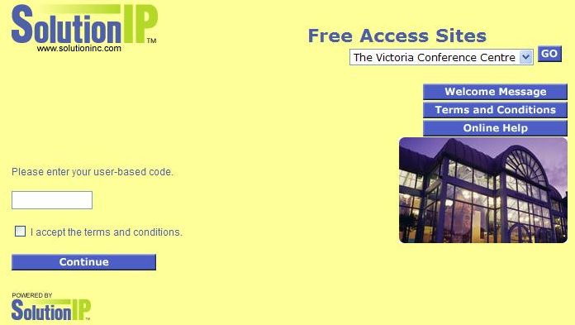
Enter the code foss4g07 (not case sensitive), check the "I accept the terms and conditions" checkbox, and click the "Continue" button.
The www.foss4g2007.org webpage should appear.

The above authorization process has to be done once each day, the first time a PC attempts to access the Internet.

