Request for Seed Funding for FOSS4G 2015
from the
FOSS4G 2015 Local Committee (LOC) to the
Open Source Geospatial Foundation (OSGeo)
initial version: 22 October 2014
updated: 17 July 2015

- The FOSS4G 2015 LOC request seed money in the amount of USD40,000 for the preparation of FOSS4G 2015 Seoul. The seed money will be managed and spent through an account of MECI International, a PCO of FOSS4G 2015.
- The seed money will be paid back to OSGeo after FOSS4G 2015 only if the FOSS4G 2015 LOC records a profit. This means that the OSGeo foundation will be responsible for any losses for the event, up to the seed money amount of USD40,000.
- If the LOC make profits out of FOSS4G 2015 Seoul, 50% profits will go to KSIS and 50% profits will go to OSGeo. OSGeo Korean Chapter and KAOS-G (Korea Alliance of Open Source Geospatial) will not take any profits.
- Regarding profit sharing, since the LOC will make use of KSIS's resources throughout the preparation of FOSS4G 2015, the LOC needs to respect KSIS's role. This will facilitate the LOC to attract more prominent sponsors and will expect more organised involvement from the KSIS.
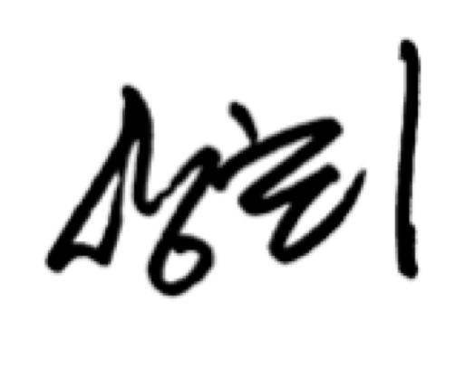


Sanghee Shin Jeff McKenna
Chair of FOSS4G 2015 President
Representative of OSGeo-Korea Open Source Geospatial Foundation

