Proposal for FOSS4G 2016
in Bonn, Germany

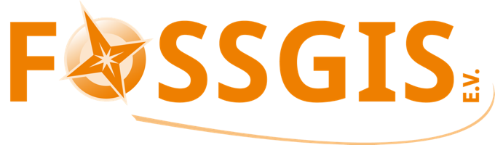


Contact:
Till Adams Marco Lechner
FOSSGIS e.V. FOSSGIS e.V.
till.adams@fossgis.de marco.lechner@fossgis.de
++49 (0)151 2539 4429

Table of contents
1 Your reasons for hosting the conference, and your goals for FOSS4G 6
1.1 Our reasons 6
1.2 Our goals 7
1.3 How will your conference succeed financially and make profit? 8
1.4 How will your conference succeed socially (giving people the unstructured space and time to meet and engage with one another)? 8
1.4.1 Socializing 8
1.4.2 Ice Breaker 9
1.4.3 Come together – the Gala Event 9
1.4.4 GeoBeer 10
1.4.5 Pub Race 10
1.4.6 Petanque race 11
1.5 How will your conference provide open source education (providing good training opportunities to new users)? 12
1.6 How will your conference promote open source geospatial software (bringing new organizations into the open source community)? 13
2 The hosting location 14
2.1 What city will the conference be in, what is interesting about it? 14
2.1.1 The Federal City 15
2.1.2 Bonn International / the UN City 15
2.1.3 Bonn, a region for Science and Research 16
2.1.4 Business 16
2.1.5 Culture 16
2.1.6 Nightlife 17
2.1.7 Some Quick Numbers about Bonn 17
2.1.8 Bonn – the Region 17
2.2 Accessibility of Bonn 18
2.3 What venue will the conference be in, what are the number of rooms available, seating, and associated pricing? 19
2.3.1 The Worlds Conference Center Bonn (WCCB) 20
2.3.2 The plenary chamber – or – the former German Parliament 20
2.3.3 The local team and WCCB – with our own words 22
2.3.4 Technique 23
2.3.5 Rented Rooms 24
2.3.6 Available workshop facilities, number of rooms, computers per room, pricing, strategy for providing workshop facilities. 25
2.4 2.18 Available rooms for additional small business meetings 26
2.4.1 What is the maximum size your venue could entertain? The minimum? 26
2.5 Accommodation in Bonn 26
3 The hosting organization and local community. 28
3.1 FOSSGIS e.V. 28
3.2 3.2 Local organizing committee. 29
3.3 Local open source development and implementation activity, interest and enthusiasm for open source geospatial in your region. 32
3.4 How do you plan to manage/organize work and relations with OSGeo (especially with the board and conference committees)? 33
4 The budget 34
4.1 What is your budget? Expenses for venue, food, marketing, audio-visual, network access, etc. 34
4.2 What is your expected attendance? Why? Where do you think delegates will come from? 36
4.3 What is your expected sponsorship? Why? Do you have local potential sponsors already identified? At what levels? 36
5 The program 38
5.1 Provide a high-level view of the program, indicating number of tracks, size of tracks, workshops, size of workshops, and other features of your program. Indicate the number of presentations, posters, and workshops you expect to accept. 38
5.2 Focal points of the programme 39
5.3 Program modules 39
5.3.1 Workshops 39
5.3.2 Plenary Sessions 40
5.3.3 Sessions 40
5.3.4 5.3.4 Labs 41
5.3.5 Poster Sessions 41
5.3.6 Catering 41
5.4 Code Sprint 41
5.5 What social events will be part of the schedule? 42
5.6 What dates do you expect to run the conference? Are they adjustable? 42
5.7 Provide a list of local/regional/international conferences around the selected date that are viewed as competition or could provide synergy. 42
5.8 ….and what about FOSSGIS ? 43
5.9 Connecting EARSeL and FOSS4G 44
5.10 ..and how could this work? 45
6 Other relevant details (ie. do you plan to use professional conference organizing service, and approximate cost) 47
6.1 Marketing 47
6.2 Our Professional conference organizing service provider: MediaCompany 47
6.2.1 Profile Media Company 48
6.2.2 Key data 48
6.2.3 The MediaCompany-Team 48
6.2.4 References (Examples) 50
6.2.5 Costs 50
6.3 Draft for the logo 50

Index of Appendices
Appendix 1 appendix_I_foss4g_2016_programm_draft
Appendix 2 appendix_II_MediaCompany-Agency-Team-References
Appendix 3 aapendix_III_McKenna-OSGEO

Appendix 4 appendix_IV_osgeo-conference-budget-plannings

Appendix 5 appendix_V_plan_rheinebene

Appendix 6 appendix_VI_Letter_supportUNSPIDER_FOSS4G

Your reasons for hosting the conference, and your goals for FOSS4G

Our reasons
The German Open Source Geospatial community is eager to host FOSS4G 2016 in Bonn.
Having been involved from the early days on, our community has "discovered" some of the core projects of OSGeo more than a decade ago and we were part of the founding and shaping of the OSGeo. Since then we have managed to grow a healthy economy around Open Source Geospatial applications, involving the public administration, businesses and academia. In addition the German community contributes significantly to the portfolio of OSGeo's projects (e.g., deegree, MapBender, GRASS, QGIS, partwise to OpenLayers 3 and other projects). The community has an even longer history in Germany dating back to the year 2000 when the community decided to form a legal entity for GRASS users. This association later became the German language Local Chapter of OSGeo (FOSSGIS e.V.) and also acts as a backstop and conference organizer for the OpenStreetMap community. FOSSGIS e.V. has a decade of experience with organizing local conferences with up to 560 participants (Berlin, 2014). 2016 is our chance to give something back to the whole community and we would love to welcome all the core developers of our fantastic software projects, invite new folks and show the world how professional things can become and still be fun.
Although the FOSSGIS e.V. is a local chapter of the OSGeo Foundation since years, we are aware that the input of FOSSGIS e.V. into OSGeo is not as extensive. FOSSGIS e.V. has a lot of activities supporting Open Source software and Open GeoData, but most of these activities are limited to Germany (“D”), Austria (“A”) or partially Switzerland (“CH”). The FOSS4G conference in Germany will help the FOSSGIS e.V. to become more interconnected to the international community and other local chapters, enabling better promotion of our common goals. One additional step is, that FOSS4G in Germany will not only be a German FOSS4G, but also will integrate other adjacent local chapters. Besides the fact that OSGeo D-A-CH already is an international local chapter, we are in contact with the local chapter of the Netherlands as well (and at least one person from that chapter has already joined the LOC).

Our goals
Besides the common goals of a FOSS4G like community building, coming together, meeting people and so on, we pursue some more goals. So we would like to put a thematic stress on linking FOSS and openData movements. That is what FOSSGIS already stands for (German OSM community) and we will take up the words of Schyler Erle in a past FOSS4G "Your software is fantastic, but it's useless .... without data".
Quite a few public administration departments in Germany has begun to evolve their own openData strategy. INSPIRE in Europe too plays a major role in the context of Open Data.
Last but not least this could find the link to EARSeL (see Chapter 5), because earth observation in the first step also elevates geodata.
When talking about possible Open data projects and initiatives or eGovernment processes in Europe, geospatial data plays a central role and geodata sets are part of each proof of concept or pioneer project for those who try to push Open data or implement an eGovernment process. The European INSPIRE directive is highly connected to OGC's open standards and GDIs, scaling down from European to local level, an important trans-national topic. Egovernance and Open data will be an important topic of the FOSS4G 2016, potentially attractive to new prospective partners.
To summarize, one of the subtitles of the conference might be "Link FOSS4G to Open Data".
One focus, which always should play a major role in FOSS4G events and which we would like to stress is a focus on the "bring people together". Our program and also the facilities of Bonn offer attendees many facilities to converge and converse.
The social factor is one of the most important one's of an Open Source community like FOSS4G, and if the conference organizer supports that with meeting places, social events during the full week etc, this will benefit all.
Last but not the least, we will celebrate the 10th anniversary of FOSS4G conference. Let us celebrate this occasion in an impressive location which had a great impact on history, like the former German Parliament and the capital – inspiration for the attendees to evolve again the special spirit characterizing former FOSS4G conferences.

How will your conference succeed financially and make profit?
FOSSGIS e.V. has a decade of experience with running Open Source Geospatial conferences with up to 560 participants attending the FOSSGIS conference each year.
Our calculation is thorough and this will ensure some returns for the OSGeo Foundation. We already have an excellent set of sponsors lined up in Germany and internationally.
On the one hand, the returns calculation scales with the number of participants in order to minimize the risk of loss. On the other hand, revenues from sponsorship, that do not scale with the number of participants, are estimated conservatively. As a result, it would be not surprising if the benefits exceed expectations.

How will your conference succeed socially (giving people the unstructured space and time to meet and engage with one another)?
In past years FOSS4G conferences have grown to a size and radiance than can hardly be surpassed. At the same time some of the more unstructured aspects had to be put aside. We will make sure that both aspects are taken into account. As expected there will be a core conference with regular presentations preceded by dedicated workshop days and followed by an open space code sprint. But - as this is a special issue marking 10 years of the Foundation - we will also dedicate specific plenary time to OSGeo, its mission, goals and future drive. We will put OSGeo back in the focus of the conference instead of making it appear as a side event. We firmly believe that the OSGeo Foundation is a key factor to further the success of the Open Source Geospatial movement and deserves to be the center of the FOSS4G conference.
In the following chapters we give a brief overview about our plans for socializing and after conference program.

Socializing
We think that in past conferences the importance of meeting outside the official program was underrated. As we celebrate the 10th anniversary of the FOSS4G conference, we plan a program where the gathering of the community is an integral part.
This is especially essential as this proposal is designed to combine two conferences and thus two „tribes“. We also plan to integrate OSGeo's Annual General Meeting more tightly into the program of the conference holding it right before the Gala Event.
Further events we've planned are listed as follows:

Ice Breaker
For the Ice Breaker we selected carefully a fascinating venue: The botanical garden of the University in the historic Poppelsdorf district. Already the walk from the central station along the Poppelsdorfer Allee (an alley) towards the Poppelsdorf Palace which was built in 1753 is already fancy.
Behind the palace, there's the world-famous botanical garden. This is a lovely place which is shamefully unknown. There is a huge collection of plants outside and in glasshouses, including the giant stinker which regularly flowers.
The location for the Ice Breaker is in the middle of the garden or in case of rain within a large greenhouse (from 7-10.30 pm). Within the garden, drinks, fingerfood and snacks will be served from several carts. It's an atmosphere that invites you to stroll, talk and meet other people. Especially for those who had a long travel, it'll be a relaxing experience. An overall classy start for a conference like the FOSS4G 2016.
The Icebreaker will be an optional module when booking. The approximate costs will be about 20-25€.

Come together – the Gala Event
The Gala Event wasn't always part of the conference, but sometimes an add on to the conference. Thus only a portion of the community was able to attend that event as often there wasn't enough room for everyone. For the 10th anniversary of the conference, we plan a big birthday party on a ship (the „Rhine Energy“) on the river Rhine. This event should of course be for everyone, hence it's included in the conference ticket price.
The ship sails south along the Rhine towards the UNESCO World Heritage Site Middle Rhine Valley. On the ship there will be a three-course meal which will be accompanied by the sound of the band „Queenkings“, a cover band which plays famous as well as not well-known songs of Queen. In the past the bassist and manager of the band was already on stage with Brian May, the guitarist of the famous rock band.
After a welcome drink the bar will be opened. It starts at 6:30pm, the ship returns at 10:30pm, but will stay open till 1am. Hence the party can keep going on the ship or shift toward the city.
The „Rhine Engery“ can accomodate up to 1100 people and can dock close to the WCCB.

GeoBeer
The purpose of the GeoBeer is to enable the uncomplicated and down-to-earth socializing between participants after the official conference program. We compiled three localities in the vicinity of the WCCB, that facilitate this function:
→ GeoBeer – Nature
Only a few meters from the entrance of the WCCB, directly at the Rhine, a Kiosk with open air seating benches offering bottled beer. At this place you have a nice view of Bonn, the Siebengebirge (i.e. surrounding mountains), the Rhine, WCCB and the UN-City, a very suitable place to enjoy a bottle of the local beer speciality “Kölsch”.
→ GeoBeer – WCCB
Directly at the Entrance of the WCCB is a Bar, which is a perfect meeting point during and after the conference days. A variety of drinks and and small snacks are offered here, that shorten the time until dinner.
→ GeoBeer – Sky
The delegates who like it more exclusive can find a suitable location to socialize at the top floor of the WCCB hotel. The Sky Bar offers a glorious round view over Bonn and the Venusberg, the Rheinaupark, into the Eifel and the Siebengebirge. On clear days it is even possible to see the Cologne Cathedral.

Pub Race
A basic requirement of socializing is that participants who want to meet people have convenient opportunities to do so. Even if you are at a medium sized city like Bonn, we think it is important to name a few places to meet other FOSS4G participants.
The bar and pub scene of Bonn consists mostly of medium and small sized bars, pubs and cafés. It would be impossible and also not suit the character of the city, if the evening gatherings would happen at a single place. Hence we choose 5 localities that we grant the status of “Official FOSS4G Pub”. This way, all FOSS4G attendees know where the community tribes can be found. On showing your conference badge, special FOSS4G discounts will be offered at these locations.
As a gimmick, participants can collect puzzle parts at each of the five spots. All five parts together yield a ticket that allows to participate in the raffle during the closing ceremony.
The Pub Race will start on the weekend before the conference and will end on Saturday, the evening after the code sprint. This allows to enjoy the Bonn nightlife during all days of the conference and also on the Gala Event and Ice Breaker nights. Pubs are closing seldom before 1 am, on weekend mostly not before 3 am, that guaranties plenty of time for meting people, socialize and have fun.
Of course, the “Official FOSS4G Pubs” are only an offer, many other restaurants, bars, pubs, and cafés in the city invite to stay.

Petanque race
Petanque is the south-western French word for bocce. For those arriving for the workshops and other early birds, we plan a petanque race. Normally when thinking about Petanque we have southern French people in mind playing their game in the heat of the dawning day.
But for many nice places in Bonn, people playing petanque in summer has become part of the cityscape. And so we introduce some of these places, so that visitors can enjoy themselves by taking a walk and getting familiar with the city, having a drink and if they want, play one or two rounds of petanque.
The following locations are scheduled:
→ Alter Zoll Beergarden
The place is located directly in the neighborhood of an old bastion with its surrounding chestnut trees, the rest of the city fortification forming the south-eastern end of the old town. Its name reminds one of the customs house, which was located here since the Middle Ages.
Today, the “Alter Zoll” offers one of the most wonderful views over Bonn to the Rhine and the Siebengebirge. Also there is a famous beer garden under a great Plane tree and a big square offering enough room for another station of our petanque race.
→ Poppelsdorfer Allee
In the middle of a busy part of Bonn, not far from the railway station, is the Poppelsdorfer Allee, a chestnut seamed alley with park benches and also a very nice place for petanque just in front of the Poppelsdorfer Castle.
→Hofgarten
The Hofgarten is in the direct vicinity of the main University building, the Kurfürstliches Schloss, the former residential palace of the prince-elector of Cologne in the city center located between alter Zoll and Poppelsforder Allee. In summer many students relax on the great lawn, under the chestnuts there are park benches and enough space for our third petanque place.
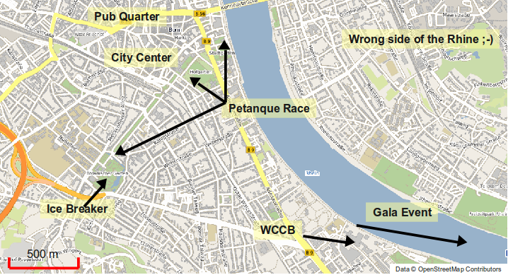The map shows how close everything is together

How will your conference provide open source education (providing good training opportunities to new users)?
The FOSS4G Cookbook (which in parts is based on the FOSSGIS Handbook) gives clear instructions on how to organize workshops, and they will obviously be again an integral part of the conference. This approach has been a good start, but in the long run we want to reach more than just a thousand conference attendees. Therefore we want to give a special focus to the GeoForAll initiative and integrate the mission "Making geospatial education and opportunities accessible to all" into the FOSS4G program. FOSS4G can be the focal point for new activities in the growing GeoForAll community.

How will your conference promote open source geospatial software (bringing new organizations into the open source community)?
It is our conviction that Open Source still needs explaining. Therefore we will include a half day information session designed to get the word out. This has been done very successfully in Denver in 2011 and is also an integral part of our local FOSSGIS conferences. In order not to preach to the converted this event is separately marketed and may take place in a separate track to specifically attract the FOSS-uneducated. This event will also include invite high-level political talks from not only Germany but also the European Commission and United Nations.
We will also try to attract all renowned geoinformatics companies around the city of Bonn for FOSS4G. We are sure, that a conference of this size and internationality will attract many people from local businesses as well. For this, the services of Ulrich Ziegenhagen, our connection to Geobusiness Region Bonn and who also heads Bonn's business development is very valuable.
Thirdly there are numerous organizations located in and around Bonn, in its state of Northrhine-Westfalia, and other places in Germany. Many non-governmental organizations and UN organizations, besides other important ones are based in Bonn. We want to invite them and let them be part of the FOSS4G Community and its happenings.

The hosting location

What city will the conference be in, what is interesting about it?
The location of the conference is the City of Bonn, which maybe a bit surprising, because everybody thinking of Germany is heading for Berlin. But Bonn as a smaller city (with slightly more than 300,000 inhabitants) might be a more valuable place for a FOSS4G where people meet each other, and Bonn has a lot of things to offer, especially a Geoinformatics focal point, and a rich history!
Bonn is one of the oldest cities in Germany founded in the first century BC. Bonn is small - almost tiny, for a city that was Germany's capital for 50 years. At the same time it is very international due to its former status, and has quite a few immigrants who came with embassies, foreign schools and businesses. This creates a very attractive conference location, not least because it is easy to reach any point of interest in no time. Bonn is perfectly accessible due to three major international airports (details below) within an hour's train ride including the European hub Frankfurt (FRA). Bonn is also at the heart of the European train network with 3 hours ride from Brussels (Head of the European Commission), 4 hours from London, and 5 hours from Paris.
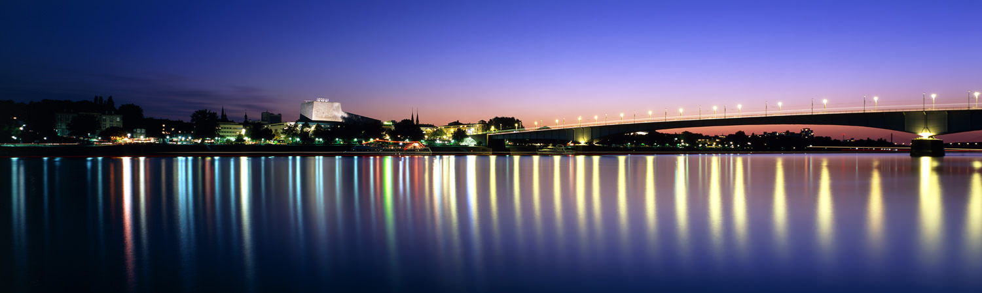City of Bonn by night, origin: website of city of Bonn www.bonn.de
Bonn is located on the Rhine River and the city's own slogan is ,,Freude", the German word for "Joy" and "Happiness". As the former capital of Germany, Bonn has kept intact its spirit of an active, open-minded city. Over the past decade Bonn has managed to shape for itself a new profile as the German City of the United Nations and a center of the international dialogue on key issues of the future.

The Federal City
For nearly five decades, the city on the Rhine was known as the place where politics were made and where politicians changed the map of Europe in the early nineties. Although many politicians moved to Berlin since 1991, politics still is in the air.
Six out of the 15 Federal Ministries still have their first seat at the Rhine, and more than 20 federal authorities have moved to Bonn in order to compensate for the loss of ministerial jobs. Thus Bonn - with the title of Federal City adopted from a Swiss tradition - has become a second political focal point within the strong federal system of the German Republic.
In FOSS4G we want to keep in touch with the political history of the city by using the former federal plenary chamber as our main conference hall.

Bonn International / the UN City
Bonn is entitled to call itself a UN City. Since 1991 a great number of organisations working in the international arena have been attracted to the city. Together with about 150 non-governmental organisations they form a strong network. The most important success in the field of international activities, however, has been the establishment of 18 United Nations Organisations, amongst them the UN Climate Secretariat (UNFCCC) in Bonn. International activities concentrate on development cooperation, ecological activities and crisis prevention. Their common denominator is "UN in Bonn - working towards sustainable development worldwide".
Since 2006 the nucleus of the international Bonn is the United Nations Campus next to the World Conference Center Bonn. The UN organisations have moved into the former office building of members of parliament. In the past few years Bonn has repeatedly proven its capacity as a convention city, by organizing large congresses. Two World Climate Summits, the International Conference on Freshwater, the United Nations Talks on Afghanistan and the Conference of the Parties of the UN Convention on Biological Diversity are just some examples.
Since the relocation of the Deutsche Welle broadcasting corporation to Bonn in 2003, the international image of Bonn is also getting broadcast world wide.

Bonn, a region for Science and Research
Embedded in the scientific triangle formed by the cities of Aachen, Bonn and Cologne, called the ABC-region and renowned as one of the key regions of scientific research and technology in Europe, Bonn has acquired an international reputation as a scientific location. The nucleus is the university founded in 1818 with about 27 000 students on campus now. In addition, new institutes, research centers and universities of applied sciences have been created during the past years.
The scientific highlight is the CEASAR foundation (Center of Advanced European Studies and Research) focusing on interdisciplinary research on future oriented themes and the corresponding marketing strategies. Last but not least, Bonn hosts a series of leading German organisations fostering and promoting science.

Business
The services sector has acquired a growing role within the economic system of Bonn, the trend shifting from public services towards private services. Major world wide operating companies have decided to establish their headquarters in Bonn, amongst them the Deutsche Post World Net and the Deutsche Telekom together with numerous subsidiaries. The IT sector alone lists about 800 IT companies which give employment to 25,000 people.
The whole region of Bonn has a strong focus on geoinformatics and besides the numerous Open Source GIS companies, who all play a global role in the Open Source community, Bonn is also home to several global players in the geoinformatics world, most of which are listed in our budget template.

Culture
Originally founded by the Romans, Bonn has a history of over 2000 years. Being the birthplace of Ludwig van Beethoven, music is an integral part of Bonn. The annual Beethoven Festival has become an important public event for the composer's works. New museums along the Museum Mile attract a large number of visitors: the Art and Exhibition Hall of the Federal Republic of Germany, the Bonn Art Museum, the House of the History of the Federal Republic of Germany, the Museum Alexander Koenig and the technological German Museum welcome more than one million visitors every year.

Nightlife
Being a student dominated city, a lot of restaurants, coffee shops and restaurants are found within walking distance from the city center. Bonn nightlife is thriving and fun-filled. Whether you want to eat, drink, party and dance all night, or sit under the stars with a local brew in hand, Bonn is the city that suits all your needs in this German city of nightlife.

Some Quick Numbers about Bonn
Bonn today is a city with over 318,000 inhabitants, ranking it 19th amogst the German cities. Bonn has always been a open and multi-cultural city, and today this is expressed by many groups of migrants from Turkey, Poland, Morocco and other countries.
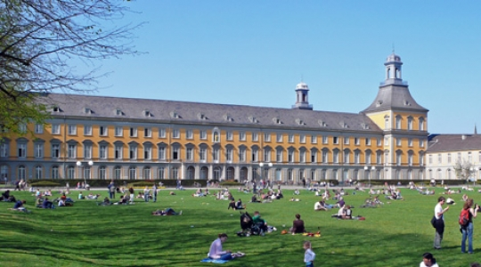University Bonn, origin: website of the City of Bonn www.bonn.de
The University with the main building, the former castle of Prince Clemens August, and its students keep the face of the city young and lively. Hotel business registers more than one million overnight stays per year.
The unemployment rate of around 7 percent is clearly below the national average.

Bonn – the Region
Bonn is said to be “The Gate to the Romantic Rhine”, because it is located directly where the Lower Rhine Valley opens from the Mittelrheintal, a UNESCO world heritage site.
A few kilometers to the south the oldest German nature reserve, the Siebengebirge, is located. This mountainous area has lend its outline for our draft logo. Attendees can discover this former volcanic area, which is crowned by medieval fortresses by boat or by hiking. A bit to the south is the Ahrtal, which is also called „the wildest daughter of the Rhine“. That is not surprising given the scenery, with the romantic course of the river, wonderful rock formations, ruins, idyllic castles and picturesque terraced vineyards.
Just half-an-hour north of Bonn you can reach Cologne with its world famous Gothic Cathedral, the Kölner Dom.

Accessibility of Bonn
With three international airports Frankfurt (FRA), Cologne-Bonn (CGN) and Düsseldorf (DUS) within an hour train distance and direct connection to the major north-south bound railway network Bonn is excellently accessible for guests from Germany, Europe and all over the world.
→ Cologne/Bonn Airport
www.koeln-bonn-airport.de
Konrad Adenauer Cologne-Bonn International Airport (CGN) is only 22 km or 20 minutes by car or bus from downtown Bonn. The airport is easily accessible by bus shuttle and taxi.
→ Düsseldorf Airport
www.duesseldorf-international.de
Düsseldorf International (DUS) currently serves 180 destinations worldwide, including 8 Eastern European countries with 21 destinations. Bonn is also directly linked to DUS via the Deutsche Bahn railway system.
→ Frankfurt Airport
www.airportcity-frankfurt.com
Germany’s largest airport (FRA), enjoys direct service from all over the world. Bonn is also easily reachable from the airport FRA via the ICE train (travel time of 50 minutes directly from the airport Distance from Bonn to Frankfurt Airport: 150 km.
→ Bonn and Siegburg/Bonn ICE Train Stations
www.deutsche-bahn.de
The Bonn region is ideally linked to the European railway system via the Bonn and Siegburg/Bonn railway stations. The Frankfurt and Düsseldorf Airports (FRA and DUS) are both quickly accessible by rail in just 50 minutes. Travel time to Bonn’s neighboring city of Cologne is only 20 minutes.
→ Public Transport
www.stadtwerke-bonn.de
The city boasts a dense public transport network, offering conference guests quick transfer options. Bonn is a city of short distances: whether on foot or by subway, street car, bus or taxi, every destination is just minutes away.
→ Highways
www.autobahn.nrw.de
Bonn is linked to the European long-distance road network via the local highway system, allowing for easy access by bus or car from both within and outside the country. The Bonn region’s excellent transportation infrastructure provides conference guests with a quality travel experience and ensures fast transfer times.

What venue will the conference be in, what are the number of rooms available, seating, and associated pricing?
The conference will take place in the World Conference Center Bonn (WCCB). It is located in the middle of Bonn’s former government district, in the immediate vicinity of the United Nations Campus, Deutsche Post DHL headquarters, Germany's international broadcaster Deutsche Welle, and next to the river Rhine.
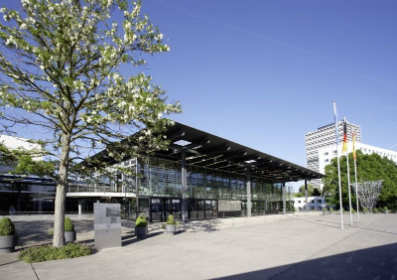WCCB - World Conference Center Bonn, origin: WCCB_website: www.worldccbonn.com
The convention center is a very unique facility – only here conferences and events can be held, where parliamentarians once debated and changed the shape of a whole continent.
On the next pages we will introduce to the venue with it's official words....

The Worlds Conference Center Bonn (WCCB)
The conference venue is located slightly south to the city center. Early birds may reach the venue by foot (about 2 km from Bonn's city center) or by tramway or bus.
The World Conference Center Bonn is located in the middle of Bonn’s former government quarter, in the immediate vicinity of the United Nations Campus, Deutsche Post DHL, the international media broadcaster Deutsche Welle, international organizations, and next to the river Rhine.The World Conference Center Bonn is just as suitable for conferences and conventions as it is for exclusive product launches or atmospheric evening events.
A nice place to meet in breaks or directly after the conference is the newly built „SKY BAR“ (see GeoBeers) on top of the new Hotel building with a wonderful view to the Siebengebirge, the Rhine and the city. This is the place where „After Conference“ socializing starts before enjoying the evening programme.

The plenary chamber – or – the former German Parliament
The conference center will be at the so called plenary chamber. That is where the German Parliament met from 1992 until 1999. The former parliament chamber, where European frontiers changed and the parliament voted for German re-union, the „Wasserwerk“ is just a few meters away. But back to the plenary chamber, we cite from WCCB's website: „The glass and steel building lies at the heart of the former government quarter in direct proximity to the Rhine.“
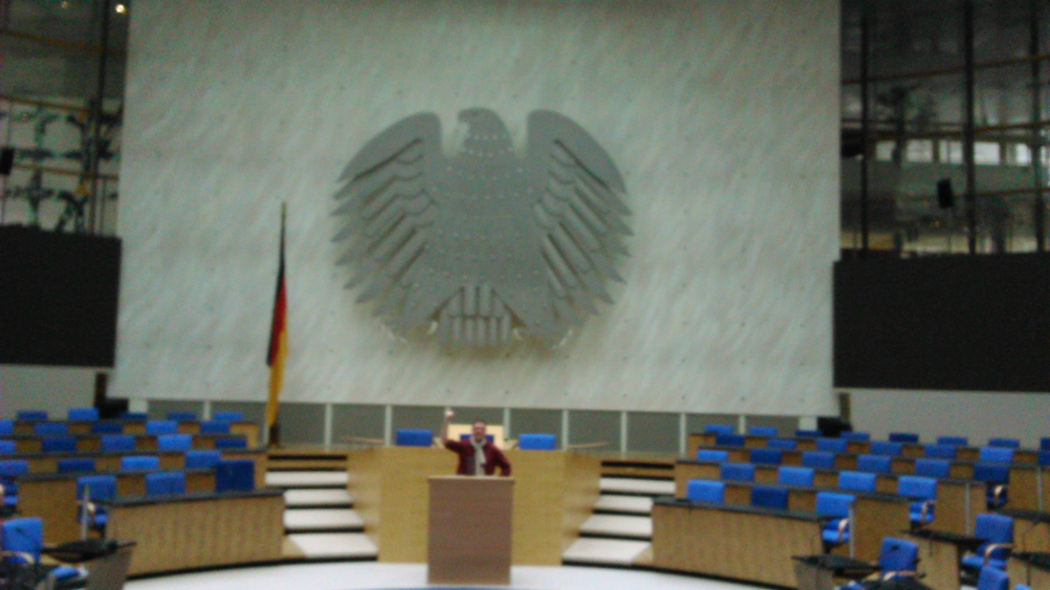WCCB - plenary Chamber with Marc Jansen, origin: Till Adams
Former FOSS4G conference „come together halls“ always have been inside – without daylight. With the transparent effect created by the glass construction, and its harmonious integration into the cityscape, the Plenary Chamber is considered to be one of the most beautiful plenary buildings in the world with a capacity for 1,230 persons to meet.
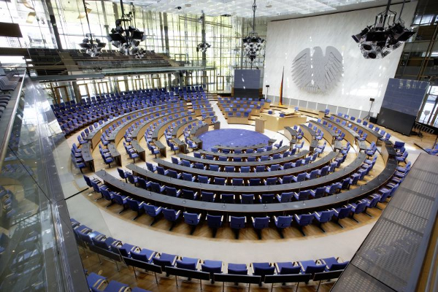The plenary chamber ... waits for FOSS4G WCCB Bonn, origin: WCCB_website: www.worldccbonn.com
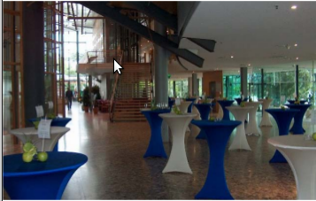The Rheinlobby (exhibition and catering), origin: WCCB_website: www.worldccbonn.com
Its entrance lies through the spacious Bundeshaus lobby. The glass walls and light steel construction create a lively atmosphere suffused by light, symbolizing democracy and political transparency. The large glass walls erected behind the chamber allow a direct view of the Rhine and the opposite bank.
Covering a floor area of 30,600 sq. m., the various rooms in the building provide facilities for various events, e.g. FOSS4G 2016 – a unique location.

The local team and WCCB – with our own words
When we decided that FOSSGIS e.V. wanted to put in a bid for FOSS4G 2016 it was just a little idea, a dream.
That this dream should take place in Bonn was clear relatively early, since the three FOSS4G-related, internationally known Open source companies WhereGroup, lat/lon and terrestris are located here. Thus the World Conference Center Bonn with the plenary chamber was an obvious choice for hosting the conference. After viewing the conference center, we are certain that this is the location where OSGeo should celebrate the 10th anniversary of the FOSS4G conferences.
The center of the conference is the light plenary chamber with its outstanding atmosphere. The WCBB is the only place world wide where you can have a symposium in a former parliamentary plenary hall. Is there any better accolade for our fantastic software, than presenting it at a place where you can still feel a breeze of history while contributing to an open future of software, data, and standards?
Additionally it's beautifully located directly at the Rhine and makes short breaks or even a longer walk through the scenic „Rheinauenpark“ along the Rhine possible.
The WCCB offers enough smaller and larger sized rooms for sessions (see below). There is also great flexibility in choosing the rooms according to the program, as the final decision needs to be made only a few weeks before the conference, and not on the initial booking.
There is also enough room around the plenary chamber for the exhibition, catering, seating, power supply and add-hoc meetings. In addition there is an outdoor area for the breaks where seats can be provided by the caterer for breaks and relaxing. Inside there are two rondels that can be used for a comeback of the FOSS4G demo-theatres.
Around the plenary chamber there is also lot of space for exhibition, catering, socket stations and also space to meet and relax.

Technique
When visiting WCCB we had an extra meeting with staff members of the technical team of WCCB. In advance, we have sent a list of requirements on the WLAN, LAN and phone technology, based on the experiences of past events. The core facts of this list were as follows:
- up to 10,000 concurrent accesses to WLAN (1000 visitors, up to 4 devices in changing positions) with sufficient IP-adresses;
- Avoiding of web-based access-sites because this always caused problems on past events and also we know, that a lot of visitors will work on the command line directly;
- many of the visitors want to download huge data packages, as announcement of new versions (i.e. QGIS 2.0 in Nottingham), which means a download of at least 1.5 GB per visitor per day;
- On past events all log-systems, firewallls, redirects and complicated proxies etc. always caused problems.
- No ports should be blocked (FTP, SSH, IRC, etc.)
There was nothing the technicians really felt alienated about. In the course of the opening of the new building, the complete LAN/WLAN technology has been made up-to-date. The connection goes over a 100 Mbit line with an active/passive 34 Mbit backup line, which could be extended.
Normally a voucher-system is used, but for our responsibility they see no problems in switching this off and opening the full WLAN for free access.
If we keep the voucher-system in use, they offer a pre/postload-site, which could be addressed to a WLAN-sponsoring site. So there is the possibility to gather a WLAN-sponsor who might take over some of the costs for technique.
Parallel to the WLAN net there is a LTE/Mimo-based inhouse mobile radio communication unit. So all traffic, that runs over GXM/UMTS will not put extra load on the WLAN.
In the exhibition area they can deliver LAN-access for exhibitors.
In general the technical guys are very familiar with higher-order requirements as they often run UN conferences where many people work together with WLAN during the conference. There will be a technical team on-site during all conference days.

Rented Rooms
- Plenary Chamber 1230 Seats, 2 Video Walls
- Room Bonn 1,2,3 181 Seats total, could be divided into three single rooms
- Room Berlin 1,2 121 Seats, could be divided into two single rooms
- Room Bangkok I (New Building) 120 Seats, could be divided into two single rooms
- Room Bangkok II (New Building) 240 Seats, could be divided into two single rooms
- Room Addis Abeba 1 130 Seats
- Room Addis Abeba 2 130 Seats
- Room Addis Abeba 3 130 Seats
- Press Balconee
- Presidential Area 1.5 Room (20 Max.)
- Presidential Area 1.7 Room (20 Max.)
- Presidential Area 1.10 Room (20 Max.)
- Presidential Area 2.5 Room (20 Max.)
- Presidential Area 2.7 Room (20 Max.)
All rooms have LCD projector, screen, flip-chart, speakers desk and sound system. Recording of presentations is also possible. A technician will be available during all sessions.
The presidential area will be used as conference office, rooms for uploading presentations and for preparation for speakers. One of them could also be used as „open program room“ for ad hoc presentations or other events.
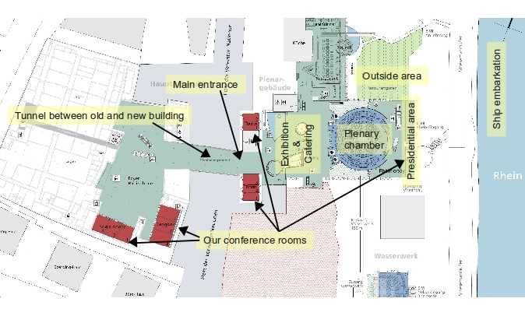Floorplan of the WCCB, origin: derived from floorplan of WCCB
N
For a bigger floorplan see Appendix V.

Available workshop facilities, number of rooms, computers per room, pricing, strategy for providing workshop facilities.
There are plans to let the workshops happen in rooms of the University or to get a sponsoring in form of free workshop facilities in rooms of Deutsche Telekom, the biggest German telecommunications provider. As this is not fixed yet we have to calculate with the most expensive alternative, to let the workshops happen in rooms of the WCCB.
We enquired for 10 workshop rooms inside WCCB, 5 with 20 and 5 with 30 seats, which allosws us to consider the expected popularity of each workshop. All toegether we may run 40 workshops happen as shown on the preliminary program sheet. All rooms are equipped with PC's/Laptops, LCD projector, presentation computer, flip chart and other regular equipments.
In our calculation we calculate with 20/30 participants per workshop, which means they are fully booked, as in past events as well.

2.18 Available rooms for additional small business meetings
As said above, there are several additional rooms in the WCCB we plan to rent. These are the named rooms in the presidential area. They give room for additional small business meetings beside the exhibition and generous allocated space around the plenary chamber.

What is the maximum size your venue could entertain? The minimum?
The plenary chamber gives room for 1230 people. As we plan the plenary chamber as the central come together room for FOSS4G in Bonn this is the maximum size we can provide.
If for any reasons early bird registrations will be far above what we expected, there is the possibility to move into what is called the new building of the WCCB which gives room for up to 4500 visitors.
The break-even point is 630 participants. The interior of the plenary chamber gives room for about 650 people (the rest is above the plenary area), so the minimum number will be somewhere at 650 visitors.

Accommodation in Bonn
Bonn has a wide selection of outstanding hotels in all categories and prices (from €30 up to €350). The World Conference Center Bonn is perfectly located within walking distance of the major hotels in the city. Within a short distance you find the largest hotels in Bonn. In addition to this a new hotel directly connected to the new conference complex is under construction and will be opened in 2015. The World Conference Center-Hotel will offer 330 rooms and suites.
All the accommodation management and hotel booking is a service from BonnHotels, the local hotel booking system for the region of Bonn run by Bonn Tourismus and Congress GmbH (T&C). It will be ensured that BonnHotels (http://BonnHotels.de) will allocate the required number of rooms for FOSS4G and it will be possible to book the hotel room allocation by phone, fax, e-mail and the Internet. There will be a direct link from the registration site to the hotel booking service.
BonnHotels conference-related services comprise:
- Arrangement of a hotel room allocation for the self-booking service made available through a hotel link. Implementation of the room allocation into the online booking site.
- Preparation of one standard booking link incl. logo implementation, to be published on the conference website and/or in any notes for participants.
- Consulting service and assistance for participants during their booking procedure by phone, fax or e-mail
- Automatic confirmation of a booking to the participant and the hotel
- Participants will pay for the accommodation at the hotel
- All hotels associated with BonnHotels.de have only favourable price offers.
- The same room package will not be offered in any other hotel reservation system for a cheaper price.
- All the bookings placed through BonnHotels.de will include a free public transport ticket valid for the duration of your hotel stay.
- The public transport ticket will be sent out as a PDF document together with the booking confirmation itself.
- The ticket is valid for traveling throughout the Bonn-Cologne Region on all public transport including the bus transfers from and to Cologne /Bonn airport.
- Last but not least, all the above listed service is free for visitors and the conference organisator.

The hosting organization and local community.
In the following we list supporting local organizations (companies, universities, user groups) and individuals that are involved in the local conference committee. In the following we will introduce FOSSGIS e.V. as local OSGeo chapter and the heads the LOC consists of.
- FOSSGIS e.V.
- City of Bonn
- Geobusiness Region Bonn
- Open Geospatial Consortium (OGC)
- UN Spider, Office for Outer Space Affairs
- University of Bonn, Department of Geography
- University of Bonn, Department of Cartography
- University of Applied Sciences, Stuttgart
- Local businesses (terrestris, lat/lon, Wheregroup and others)

FOSSGIS e.V.
The FOSSGIS e.V. (a german "Verein", and therefore a legal non-profit entity comparable to a member association) is the german speaking chapter of OSGeo for the so-called D-A-CH-Raum including Germany, Austria and the German speaking parts of Switzerland. FOSSGIS currently is supported by almost 200 paying associated members.
The main focus of the FOSSGIS association is to advance and spread Free and Open Source Software in GIS, support the growth of free and open data and promote the use of open standards. The precursor of the FOSSGIS is the GRASS Anwendervereinigung which was founded in 2001 actually predating OSGeo and even FOSS4G by a few years. :-)
Additionally to most other OSGeo local chapters, FOSSGIS has a strong focal point on the german speaking OpenStreetMap community acting as the legal entity for OSM in Germany in many cases.
Our main yearly event is the FOSSGIS conference. It started as a „German speaking UMN MapServer user conference“ in 2003. Events in the past years saw at least 400 attendees, last year in Berlin we reached 560. Although only in German language FOSSGIS nowadays also attracts visitors from other local OSGeo folks, especially from our adjacent countries, e.g. members of the Dutch, Belgian, Czech, Italian and Danish local chapters.
FOSSGIS e.V. directly supports OpenSource communities by sponsoring Code Sprints and runs events focusing on connecting communities and development groups. Every year FOSSGIS organizes a hacking weekend to further the goals of the association.

3.2 Local organizing committee.
We have the confirmation to support FOSS4G 2016 in the event that it comes to Bonn in Germany from a lot of active members from a broad range of organizations including business, government, universities and research institutes.
For now we will present the people being active in the proposal more in detail:
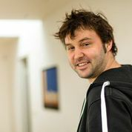
Till Adams - our conference chair. Till is one of the founders of the localFOSSGIS conference and joined his first FOSS4G in Minneapolis in 2005, when the conference name even wasn't FOSS4G. Till put a lot of effort into local and regional community building, especially in for the FOSSGIS local chapter, where he is member of the managing board.
In his main job he is founder and managing director of terrestris, an Open Source GIS company involved in especially webbased FOSS4G software-development. Till is actively working with FOSS4G Software for more than 10 years.
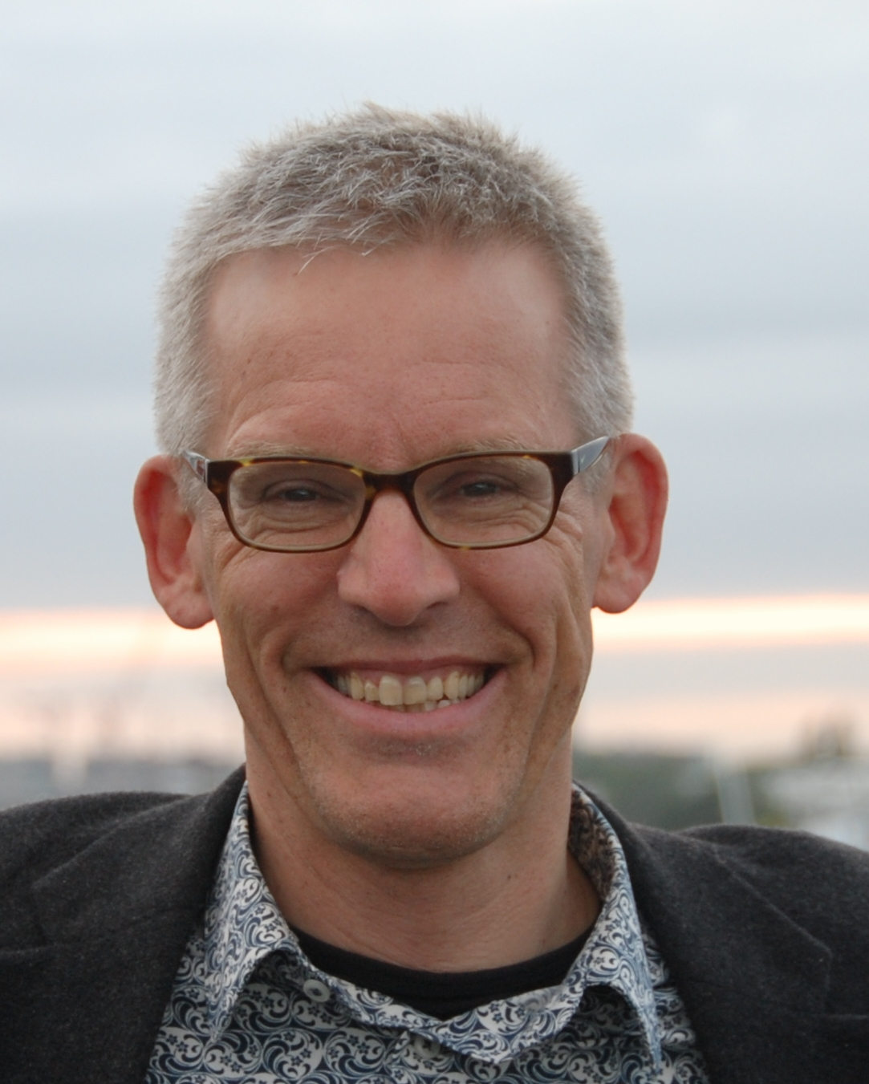
Gert-Jan van der Weijden - Gert-Jan is since 2013 president of the Dutch local Chapter OSGeo.nl. In this role, he was heavily involved in the organisation of the yearly Dutch OSgeo.nl day. His main goal to broaden the outreach of Open Source Geospatial, Open Data and OpenStreetMap. Therefore, his contacts, articles and appearances reach not only into the Open Source community, but also in the less-open parts of "Planet Geospatial".
For FOSS4G 2016 his main task will be to act as a "linking pin" between theGerman-based organization and the Dutch-speaking community, thus promoting the cross-border nature of FOSS4G.
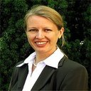
Athina Thrakas - Athina Trakas is Director for European Services at the Open Geospatial Consortium (OGC). In her position she is the contact person for OGC in Europe, responsible for the OGC’s activities and networking in Europe.
This includes raising awareness of OGC standards by technology providers and users, connecting with European stakeholder organisations, the European Commission and members, supporting regional and national forum activities and planning and managing of OGC outreach and recruitment. Athina also has a strong focus on the OpenSource community and in her role, she acts as our connection to OGC.

Arnulf Christl - Arnulf Christl is Geospatial Systems Architect and director of metaspatial. He works globally as consultant, innovator, prototyper and project manager for a range of clients.
He frequently appears at conferences, workshops and seminars. Arnulf has been founder and president of the OSGeo foundation for many years. We think, there is nothing more to say about the work of Arnulf in the international FOSS4G-community.
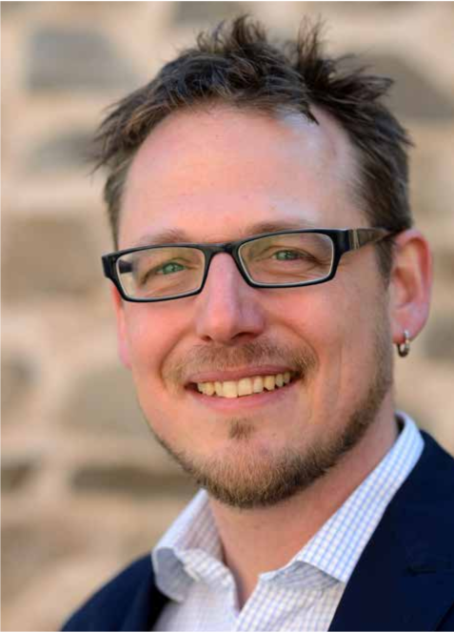
Dr. Marco Lechner - Marco is the president of FOSSGIS e.V., the german speaking local chapter of the OSGeo and manages his eighth FOSSGIS conference this year.
Marco will take care about all kinds of issues in the LOC and especially for all issues, where FOSSGIS-people get involved. In his main job Marco is project manager and developer of geospatial projects and processes in an Open Source company. He's a professional lecturer for many OSGeo software projects. In his second live he is an political activist for Open Data and Open Strategies in general.
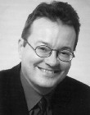
Prof. Dr. Klaus Greve - Klaus is Professor at the University of Bonn in the Deptartment of Geography. Klaus is working with Geospatial Software since many years and also was Co-Founder of lat/lon. He is our connection to the EARSEL organization and also to the University of Bonn. Klaus will be the main organiser of EARSEL conference. We also plan at least to host the code sprint in rooms of the University, so there is a strong need to have direct link to University as well.
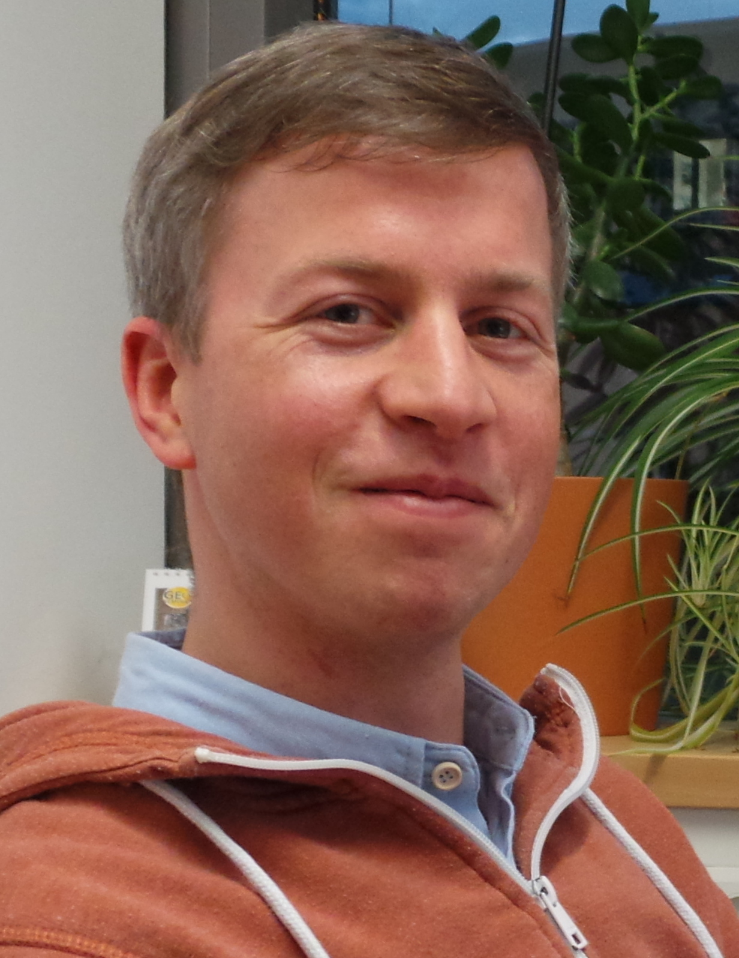
Christian Willmes - Christian is PhD student in Geography/GIScience and Research Assistant at the GIS & RS Group of the Intitute of Geography at the University of Cologne. He studied Geography, Computer Science and Cartography at the Universities of Cologne and Bonn. He applies and advocates Open Source GIS technology in research and teaching. Since an intership at WhereGroup in 2007 he is involved with FOSSGIS and OSGeo, and is a regular attendee and speaker at FOSSGIS and FOSS4G conferences.
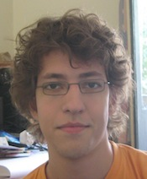
Volker Mische - Volker is a developer and came in touch with the OSGeo in 2008 in Australia. Since then he attended all global FOSS4G conferences. As a proponent of open source, he has contributed to various projects, such as OpenLayers, GeoNetwork, CouchDB and his own project GeoCouch.
Volker has good experience in contributing to the FOSS4G programm committee (2009 and 2014) and will support the LOC in this field.
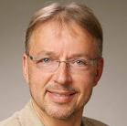
Prof. Dr. Franz-Josef Behr – Franz-Josef is Professor of spatial information processing at Stuttgart University of Applied Sciences. Franz-Josef is also Member of the DIN working group, Co-founder of Applied Geoinformatics for Society and Environment and FOSS4G Southeast Asia 2012 and Head of the HFT ICA-OSGeo Lab.
He also was Co-chair of the Academic Track of the FOSS4G's 2013 and 2014. He also is reviewer for ISPRS Journal of Photogrammetry and Remote Sensing, the International Journal of Geographical Information Science, Transactions in GIS, Natural Hazards and Adjunct Faculty at IIITM-K, Trivandrum, India. Franz-Josef will be the chair of the academic track of FOSS4G 2016.
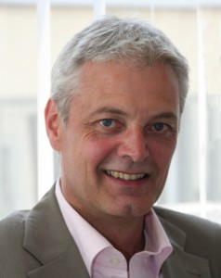
Dr. Ulrich Ziegenhagen – Ulrich is Deputy Director of the Office of Economic Development of the City of Bonn and in this function the cluster managemer for the Geoinitiative Bonn / Rhein -Sieg / Ahrweiler. He also is chair of the entrepreneurial initiative Geobusiness Region Bonn.
From his position we integrate Ulrich especially for gathering sponsoring from local companies. Ulrich is also our connector to all activities which have the necessity to be co-ordinated with the City of Bonn.
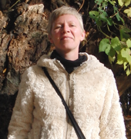
Katja Haferkorn - Katja is geographer, networker and member of FOSSGIS e.V. She has been coordinating FOSSGIS-conferences in detail since years and is responsible for the FOSSGIS conference becoming more preofesional year by year.
She will look after the Conference bags, T-Shirts, Artworks, Catering and Public Relation simply all things she does well on FOSSGIS-Conference. She has good contacts with potentially sponsors and many participants of FOSSGIS-Scene.
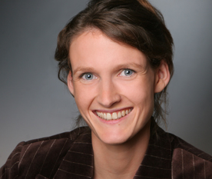
Antje Hecheltjen – Antje is Associate Expert for GIS and Remote Sensing in the Bonn/Germany office ot the Platform for Space-based Information for Disaster Management and Emergency Response (UN-SPIDER) of the United Nations Office for Outer Space Affairs (UNOOSA). She is responsible for remote sensing, knowledge management, outreach, and technical advisory activities. Before starting with UN-SPIDER in 2012 she was a research associate at the University of Bonn where she was involved in a variety of remote-sensing-related research projects mainly focussing on land use and land cover changes, while also working as a consultant for the United Nations Convention to Combat Desertification (UNCCD).

Local open source development and implementation activity, interest and enthusiasm for open source geospatial in your region.
Bonn is something like the core area of Open Source GIS Business in Germany. There are three larger companies supporting actively incubated OSGeo projects – lat/lon with deegree, Wheregroup with Mapbender and terrestris contributing actively to OpenLayers and other OpenSource projects.
Bonn, also called the Silicon Valley of geoinformatics, is a core area of GIS business in general as all bigger GIS providers have their office in Bonn. We plan at least to involve all these companies and try to gain most of them as sponsors.
All local companies and also some regional public administrations working in the field of geoinformatics are organized in the entrepreneurial initiative “Geobusiness Region Bonn“ (http://www.geobusiness-region.de/). Geoinformation and region Bonn are a brand that is capable to gather further expertise and capital to attract one growth-oriented and young industry.
Other activities are supported by FOSSGIS e.V. with sponsored Code Sprints (yearly the Bolsena Code Sprint, GeoExt Codesprint 2013 in Bonn, the Vienna Code Sprint 2014, OSGeo Code Sprint Philadelphia 2015, e.g.), annual hacking weekends and also by supporting projects. Every person or organisation may apply for sponsoring at FOSSGIS e.V. for projects dealing with Free and openSource software.

How do you plan to manage/organize work and relations with OSGeo (especially with the board and conference committees)?
Members of the Local Organizing Committee have served on the OSGeo conference committee in earlier years, have been on the OSGeo board of directors and also drafted considerable parts of previous FOSS4G events.
The conference will be managed following a clearly laid our plan and the LOC chair will inform the OSGeo board of directors and conference committee on a monthly basis. It is not expected that there will be a lot of help coming from OSGeo but major decisions and especially changes in plans will be communicated immediately so that OSGeo can take a position.

The budget
Important for the understandin of our budget planning is the budget planning sheet, which is attached in appendix IV.

What is your budget? Expenses for venue, food, marketing, audio-visual, network access, etc.
The overall planned conference expenses are in the most conservative estimation about 518k Euros. There are several chances to lower expenses massively. The most important are:
- Connection of FOSS4G and EARSeL as lined out in chapter 5 „the program“ could save us up to 65.000 Euros for venue rentals. As lined out, in case of acception of our bid, this is more or less the decision of OSGeo.
- In general the office of WCCB indicated, that a general discount of 10% for venue rentals is possible. In case of supplement to our proposal we will work on that as well. 10% might save us 6.500 Euros.
- Get a sponsorship or the opportunity to let the workshops take place outside WCCB would lower our expenses by up to 30.000 Euros, we had to calcultate for venue and PC rentals for now. We would favor to put that money into lowering the workshop fees. Of course that has to be discussed with OSGeo.
All together we see a very good chance to get another place for the workshops or to lower costs by connecting FOSs4G with EARSeL.
- Depending of who will be official organizer ahead to the german finance office (in words, if FOSSGIS e.V. will be official organizer), there is a good chance to reduce VAT for some expenses for the core conference as FOSSGIS e.V. has an official status as charitable organization in Germany. This will reduce VAT rate from 19 to 7% for all venue (rent, technique, security, cleaning, etc.) and conference organisator costs and may save up to 26.000 €. For this information we had a quick contact to our tax accountant and this has to be clarified in advance.
We have calculated this scenario in our budget planning sheet right at the end (Line 131 to 144).
- Another opportunity to lower the expenses and also the conference fee opens up, if OSGeo decides to calculate the gala event separately. In that case fewer people may attend the gala event and a smaller ship could be rent. Certainly the gala event is one of the most important sessions of the conference to bring people together.
- A big matter of expense is the catering. But we see realistic chances to lower the daily of 50€ per person flat charge, when having a brief look at food selection and hearing with the WCCB-caterer. The flat rate includes hot and cold drinks all day, snacks in the morning and afternoon and a three course lunch package and also service, dishes etc.
We plan with a revenue of 521k Euros assuming 650 attendees, 1000 sold out workshops (early bird) and including the Gala Event. Thus 650 attendees is our break even point leading to conference fees that are about at the same level than 2014 in Portland (570€/646$ for early bird and 660€/748$ regular registration). Furthermore we calculated carefully with 10% loss for complementary and free registrations which is at least the upper bound.
Also on the revenue-side, we calculated revenue through sponsorship very conservative as well, by taking only 50% of the probable incoming fees for sponsorship into consideration according to the table in the conference budget template.
Costs for our conference organizer are mainly independent from the number of attendees, so this is a fixed calculation point beside 1% fee for encashments.
The overall costs have been decreased by replaying some tasks, usually done by a hosted conference organizer with voluntary work, such as reception and help desk. There is no doubt, that we can run these jobs with our members and volunteers, as we do this on our yearly FOSSGIS conferences.
To get a reliable calculation, we assured all major expense factors by official offers (WCCB rooms&technique, catering, ship, band, conference organizer, including even covered external costs such as printing, marketing etc.). Prices for bags, and shirts derive from our own dependable FOSSGIS calculations.
All together, we can say, that this very careful calculation allows us to state, that there are lots of possibilities to better the budget, but it is unlikely, that it becomes worse.

What is your expected attendance? Why? Where do you think delegates will come from?
We await to break the benchmark of 1000 visitors for the FOSS4G 2016. This expectation is based on experiences from current FOSSGIS conferences and FOSS4G events, which constantly grew over the last years.
We do not expect all regular visitors of FOSSGIS conferences to attend at FOSS4G due to the language barrier, the part-wise different communities and also the fact, that the FOSSGIS conference always attempts to keep costs for attendance as low as possible (2015 140.00 €). Nevertheless we expect at least about 400 people from Germany, Switzerland and Austria, because we are sure our program and the FOSS4G itself attracts people, who can't be reached by a FOSSGIS conference. Also, as lined out at another place of this proposal, Bonn is a core-area of Geobusiness in Germany and in Europe as well. This is an important pull factor and supports our expectations.
It goes without saying, that the core of the FOSS4G community will attend including a strong count from North America and also umpteen visitors from other European countries. This since the past two FOSS4G's (Portland, Oregon and Seoul, Korea) in 2016 have been a long way to travel especially for European visitors.
On an European level, we noticed an increasing number of attendees from neighbored countries such as Belgium, Netherlands, Switzerland, Denmark, Czech Republic and Poland on our FOSSGIS conference. We hope and are sure, that an FOSS4G located in Bonn and therefore located in the middle of Europe allures participants from all over Europe and all over the world in a similar way.

What is your expected sponsorship? Why? Do you have local potential sponsors already identified? At what levels?
For our calculations we used the spreadsheet in the budget document to get a brief overview. Although we are in an early stage of planning, numerous sponsors, especially from local Geospatial companies, are expected, because Bonn has a cluster of German and European GIS companies.
The prices are based on previous years events, but we slightly decreased the pricing for bronze sponsorship in order to lower the threshold especially for smaller companies to join. We also divide the sponsorship structure into „Bronze with exhibition“ and Bronze only supporter“. The FOSSGIS Geospatial community consists of some companies with staff-sizes of 2 up to 10. Some of them will not be able to exhibit, but regardless will like to support the FOSS4G.
Proposed levels of sponsorship
- Platinum 30000
- Gold 15000
- Silver 8000
- Bronze+Exhibition 3500
- Bronze (Supporter only) 2500
As said before, that although we expect a sponsorship which achieves at least the level from past events, we reckoned very carefully. In our budget planning we only calculated with 50% of the expected sponsorship due to the sponsorship table in appendix IV.
Outbalancing this level in an early stage of the conference preparation, gives us and the mentors of OSGeo room for either more outcome, more conference highlights or reduced conference fees.

The program

Provide a high-level view of the program, indicating number of tracks, size of tracks, workshops, size of workshops, and other features of your program. Indicate the number of presentations, posters, and workshops you expect to accept.
All conferences are somehow defined by its program, but we think that especially for FOSS4G's the program is one of the most central parts of a FOSS4G conference. And there are several important facts to include: normally software conferences lack of talks by developers of the software, but this is different for FOSS4G and it's an important part of FOSS4G – see, hear and meet developers of the software behind. Keeping in mind, that the free availability of (geo-)data is a crucial and, saying this, that also the academic track is a very important part of FOSS4G programs, we are in a magic triangle of these three factors. So we see. That the magic is to join all this together in a diverting, informative and somehow stimulating program, which...
- has to be diverse but also self-contained
- contributes to the publicity and development of OSGeo and other Free Software projects
- keeps in mind that access to free data plays a major role
- also provides knowledge for decision makers
- delivers the opportunity for delegates to meet with developers and like-minded
- offers the opportunity to discuss and share ideas and open ways for new relationships to develop across the community
A conference where up to 1000 visitors are expected must offer a variable, open and very interesting program. Especially we as FOSSGIS e.V. have already gathered a lot of experience in this field. One important parts for us is to see the success and rising numbers of participants at our own conference, the FOSSGIS. Taking all this together, we want to create a diverse program for everybody, formed of distinct tracks but united over the key themes.
A key role for a successful conference program comes up to the selection of the speakers. For this the community is the best adress, so we favour, as on other FOSS4G's before, to let the community vote with adequate tools. But also there will be a program committee, which should consist of a cross section of the community which will reserve the right to retain the final decision on selection, just as this has been the case in previous FOSS4Gs as well.
Having seen many FOSS4G's before, we believe, that another very important part of the program is “space & time“. The venue, WCCB, offers the space for spontaneous meetings and sessions, we, as the organizing committee as a whole want to offer the time in form of breaks, BoF-sessions, social events and evening happenings so that visitors can meet, discuss and share ideas and knowledge.
We've added Appendix I, our “program draft“ which can be the framework of the program. This is planned as a „classic FOSS4G program“ with 2 days of workshops before the conference, three days core conference and a closing code sprint day on saturday.
As said in the chapter about WCCB, the venue facilities are nearly endless flexible and give us enough room to adjust our first early program plannings to the real needs.

Focal points of the programme
As lined out in other parts of the proposal, beside „normal FOSS4G program-business“ we see focal points for the program in the following fields
- Free and openData, Data aquisition and INSPIRE
- GeoForAll initiative and the mission "Making geospatial education and opportunities accessible to all"
- Seperated information session designed to get the word out
- Focus on the Academic Track

Program modules
In the following – although known by most of attendees, we shortly introduce to the different kinds of planned program-modules.

Workshops
Workshops form a very important role to give attendees the chance to get hands on the software and we are aware, that for some of them this is the chance to gather their first FOSS4G experience. For this, it is very important to have the people behind the software-projects to run the workshops. In order to promote this, we plan with as much workshops as possible.
We requested for 10 workshop rooms with PC's/Laptops, 5 with 20 and 5 with 30 seats, so we can consider the expected popularity of each workshop somehow. With 2 workshops per day and room, we can accept 40 workshops, which is the same capacity as FOSS4G 2014. If needed, we can get two additional workshop rooms, so the absoulte capacity would be 48 workshops.
If the workshops take place inside WCCB, we can get a reduced lunch package including softdrinks and coffee from the caterer for 25€ per person per day.

Plenary Sessions
Plenary speakers form the frame of a conference, but as we understand Open Source and community, plenary sessions are only one part of a successsful conference. So we want to have plenary speakers, but we also understand that the FOSS4G community is formed by many, many individuals. For this, we do not want to overrate plenary session at the expense of broad sessions. As compromise we plan with 7 sessions to parallel, there are enough conference-rooms and one in the plenary chamber for more outstanding talks. This allows us to go for both, having talks of so-called “FOSS4G-heroes“ and also parallel with a broad program with many key features.
Besinde the opening (90 minutes) and closing session (90 minutes), we plan two short (30 minutes) come together sessions in the plenary chamber, where to introduce into the day and also announce important changes. The rest should be run in the parallel sessions.
Inside the plenary sessions we favour keynotes and classical lightning talk sessions.

Sessions
Sessions are the chance for everyone to present his or her ideas, work and contribution to community. The program framework as setup for now gives us room for at least 209 session-slots, each with 20-25 minutes talk and some minutes for questions and discussion. In this early stage, there is enough flexibility to change this, if wanted and needed.
All rented rooms inside WCCB are very close together, so that changing during the sessions will be possible. In order to keep this as calm as possible, we know, that time-discipline is very important and we will instruct the session-chairs appropriate.
This is in general what's normally possible on a FOSSGIS conference and keeps the attendees as free as possible in their choice to see, what they are interested in.
As we also plan a strong focus on the academic track and as learned from other FOSS4G, there might be one fixed room for the Academic Track sessions. This prevents people interested in that track from changing to often. But that is just an idea and has to be discussed finally later.

5.3.4 Labs
Labs are kind of workshop-sessions. For this ealry stage, we have planned with one track lab-sessions for now, but there is the possibility to extend this if needed. For now there are 8 slots for free labs (5 for 90 minutes and 3 for 120 minutes). In times we have short sessions (1 hour) the labs-room is free for other spontaneous activities such as business-meetings, open-space-sessions or BoF's.

Poster Sessions
As there really is a lot of space around the plenary chamber, it is hard to restrict the number of accepted posters, as long as the quality is fine.
We plan two official poster asessins where poster-presenters are expected to stand beside their posters during lunch of the first two conference days. Another idea is to combine poster sessions and Academic Track.

Catering
There will be drinks and coffee available all day. For the morning and afternoon breaks we plan with additional fruit and pastries. For lunch the caterer plans with a three course buffet. As there is a lot of room, the caterer can plan with several food banks. It may be helpful to adjust the closing time of some of the sessions slightly, so that not all attendees will enter lunch at the same time.
The catering costs about 50€ per person per day (including all services, dishes, etc.).

Code Sprint
Of course the traditional Code Sprint on the day after the core conference is scheduled. We plan to run the Code Sprint outside WCCB in rooms of the University. If there are other needs for further sprints, we think that also rooms on sunday would be available. We will communicate this to the community in an ealry stage, so that we can do the plannings.

What social events will be part of the schedule?
See the chapter “socializing“ for our planned social events.

What dates do you expect to run the conference? Are they adjustable?
Traditional FOSS4G month september is a little different month for Bonn, as several festivals, conferences and so on will happen. This increases prices for the venue and overnight stays and decreases availability of accommodations at the same time.
In the moment we plan to run the conference end of August with the core conference starting at wednesday 24th of August. In this early stage adjustment is possible.
On the other hand, this dates dissolves us from InterGEO. In the past years FOSs4G and InterGEO, which is traditionnally mid of september took place at the same time. The late August date will prevent this.
In case of FOSS4G comes to Bonn and we will succeed to connect EARSEL (see next chapter) and FOSS4G we think, there must be a discussion between EARSEL, the LOC and OSGeo about the conference dates, as UN conferences must schedule in the official UN conference scheduling plan.

Provide a list of local/regional/international conferences around the selected date that are viewed as competition or could provide synergy.
There are a lot of greospatial conferences all over Europe conferences. Some of them are listed here
- AGIT – the AGIT symposium normally takes place end of late June/early July in Salzburg
- FOSSGIS – FOSSGIS conference is planned to take place together with the AGIT in early summer 2016 (also see following chapter)
- InterGEO – the InterGEO is the worlds biggest trade fair for geoinformatics and has long time been in concurrence to FOSS4G's date. InterGEO 2016 will be 11th-13th of October in Hamburg
- FOSS4G Europe has become a yearly event. In 2014 it took place in early July in Bremen, for 2015 it is mid of July in Como. We will get in contact with the FOSs4G Europe people to prevent time and spatial proximity or we might integrate FOSS4G 2016 Europe into Bonn's FOSS4G.
- Deutscher Kartographentag u Geoinformatik 2016, Potsdam, Germany, 14.-16.6.2016
- XXIIIrd ISPRS Congress Prague, Czech Republic, 12.-19.7.2016

….and what about FOSSGIS ?
The FOSSGIS is the conference organized by FOSSGIS e.V.. FOSSGIS is taking place every year, normally around mid of march. We started in early 2003 (named as UMN Mapserver Conference) and since then had an increasing number of visitors, resulting in about 560 visitors in Berlin in 2014.
After the LofI-phase, Jeff McKenna asked us to write about our plans with FOSSGIS 2016. Although the names of the conferences are related, the character of the conferences is quite different. FOSSGIS has always been the german speaking conference and has always been more kind of user's conference, while FOSS4G has always been an international conference with strong focus on developers-meetings, science and also business. For our FOSSGIS we always try to keep prices as low as possible, so we normally seek organizing committees with a strong link to Universities. Another fact is, that since 2008 FOSSGIS also stands for the German speaking chapter of OpenStreetMap.
On the other hand there is FOSS4G and part of the character of FOSS4G is internationality, community Taking all this together, we think that both conferences are slightly different, although they come from the same community. A lot of people visitng FOSSGIS are from german public administrations and have never been to a FOSS4G. This also because traveling outside Germany often causes problems with the employer.
Putting all this together, we think, that joining FOSSGIS into FOSS4G, at least with a german track is not really what we want. Especially on the 10th anniversary of FOSS4G (and also 10 years after the first so-called FOSSGIS-conference took place in … Bonn) we want a pure, 100% FOSS4G as it ever was.
For 2016 we have the possibility to let FOSSGIS 2016 take place in a reduced frame in connection with the AGIT symposium in Salzburg, Austria. Doing so, has several advantages:
- FOSSGIS is the german speaking conference – which includes Austria. And for those, who can't go to Austria, can and are expected to join FOSS4G. We have seen in 2013, when FOSSGIS was in Switzerland, that the number of participants especially form Germany was lower than on normal FOSSGIS conferences.
- FOSS4G remains in its original speech and we do not artificially want to haul a seperation of visitors because of different tracks in different languages inside one FOSS4G conference
- Both conferences take place at different dates, so it's enough room to join both for those, who want to (AGIT will take place end of June/early July)
- Organization power from german members remain for FOSS4G, while efforts for FOSSGIS conference supported by the AGIT team

Connecting EARSeL and FOSS4G
There is a really good chance to connect the EARSEL conference with FOSS4G. We are in close connection to the EARSeL organizing committee, especially in person of our LOC member Prof. Dr. Klaus Greve, who will organize EARSEL 2016 in Bonn. Klaus derived the idea to link both conferences. In Annex III there is an official letter of the mayor of Bonn and also of the president of the University of Bonn, sent to Jeff McKenna, in which they strengthen their wish to let both conferences take place at the same time in Bonn.
EARSeL is a scientific network of European remote sensing laboratories, coming from both academia and commercial/industrial sector, which covers all fields of geoinformation and earth observation through remote sensing.
All scientists, professionals and researchers involved or interested in the field of the symposium are strongly encouraged to present papers according to the following topics:- Scientific applications of remote sensing, emerging methods and technologies-Education and training in school, university, and public life- Capacity building at organisations and authorities involved in environmental monitoring and protection- Activities dealing with natural and cultural heritage- Remote sensing for archaeology- Land use and land cover, degradation and desertification- Urban remote sensing- Oceans, coastal zones and inland waters- Natural and man-made disasters- Forestry and forest fires- Applications related to assist developing countries:
mapping, monitoring and change analysis- Remote sensing and its associated support to the understanding of climate change- Hydrological applications: water management, underground water sources, land ice and snow- 3D remote sensing, Radar, Lidar, Thermal Remote Sensing- New instruments and methods, including ground truth
We think that especially under the motto of data (remember Schuyler's “Your Software is useless without data...“) the connection of two communities, the FOSS4G and Remote Sensing community is a very good chance for both communities for getting connected.
Beside that, there is the fact, that both conferences linked together will get the official branding as “UN Conference“, which will ennoble our FOSS4G in our eyes and drive attention to our doings from totally different perspectives.
Another side effect is, that if we get this “UN-branding“, the city of Bonn will discount the room rent for WCCB (which is owned by the city of Bonn) by 90% (!!!). This will reduce expenses for WCCB from around 70.000 € to 7.000 €.
If so, we can discuss with OSGeo conference committee and also the board whether we will reduce the conference fee or take the money as outcome for OSGeo. One thing to keep in mind, is that, if the Bonn proposal gets accepted, we will have to discuss this point pretty soon.

..and how could this work?
EARSeL expects around 350 visitors and works exactly the other way around. Traditional conference core days are Monday to Wednesday and afterwards workshops take place. So a linked conference could start at Monday with EARSEL opening and workshops for FOSS4G. After the FOSS4G opening there could be main talks in the plenary chamber connecting both worlds. The inquired rooms give enough space to run both conferences in the same building that day and even to host an aimed turnout of more than 1300 perons. From Thursday on, normal FOSS4G conference and EARSeL workshops will take place. People from both conferences have also the chance to visit both core conferences and people could meet during the pub race.

Other relevant details (ie. do you plan to use professional conference organizing service, and approximate cost)

Marketing
We, the LOC do not simply rely on the FOSS community to turn-up attendees for FOSS4G. We also be awar, that attendance on a FOSS4G is a significant financial undertaking and some people wanting to attend on FOSS4G have problems to gather the money or can't justify attendance. In order to help at least these people, we plan to actively support them with informations and attract decision makers to understand the importance of FOSS4G. This will also help to enlarge the group of potential attendees and to accomplish our target audience
FOSSGIS e.V. and so some members of LOC have a lot of experience doing so, as we do the same for FOSSGIs conference each year. Doing so, we use our press distritbutor, mailing lists, chats, e.g. but also use social media tools such as Twitter, Facebook, Google+ or LinkedIn. For all this we have a marketing budget in order to set up materials and enhance our ability to broadcast them globally and regionally.
Another step for marketing would be the announcement of FOSS4G coming to Bonn on this years FOSSGIs conference, taking place mid of march. With that alone we would reach about 500 people and with that having set a good base for distribution for word-of-mouth-advertising.

Our Professional conference organizing service provider: MediaCompany
Of course we are planning to involve a professional conference organizer. For this, we decided to work together with the MediaCompany. This because they are ver familar with the venue, the WCCB, they have a lot of experience with conferences at our size at all and especially in this venue. And, last but not least, they are locally from Bonn. In the making of this proposal we had a very uncomplicated form of communication with them, which fits very well to the spirit of a FOSS4G.
In the following we will let them to introduce themselves shortly, but we've also added a full „Agency Team References“ in Appendix II.

Profile Media Company
MediaCompany conducts PR work in the social and political area. They are passionate about complex topics of relevance to society, and dealing with these credibly and convincingly is their core business. They have been working successfully with this for 21 years, for national and regional institutions, associations, companies, and non-profit organisations.
MediaCompany is an owner-managed agency with currently have 35 permanently employed and highly committed staff members. As a team, they cover the full spectrum of PR services. They understand as partner for strategic advice, public relations, public affairs, social marketing, advertising and live communication.

Key data
Agency type: Communications agency
Legal form: GmbH
Year of founding: 1991 (Bonn), 2000 (Berlin)
Directors: Holger Baum, Stephanie Müller
Locations: Bonn, Berlin, Düsseldorf, Hamburg
Employees: 35 regular employees and 8 freelancers
Certificates:
"Oekoprofit" - Certificate for sustainable and ecological responsibility
"fairpflichtet" - Sustainability Code of the German event industry

The MediaCompany-Team
Amy Sandweg - Project Leader Live Communication
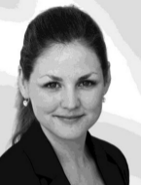
Amy Sandweg is a German studies graduate and cultural scientist and has been responsible for project management at meetings and conferences as Live Communication Project Manager at MediaCompany since 2011. Before that she organised events in the socio-political sector and was involved in the public relations work for the initiative 'Lokale Bündnisse für Familie (Local alliances for families)' by the Federal Ministry for Family. She was raised bilingually (German/English) and became a certified sustainability consultant for the event sector in November 2013.
Conrad Seyfert - Project Leader Live Communication
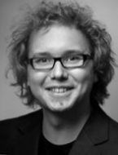
Conrad Seyfert is a qualified media scholar and has been Project Manager for live communication at MediaCompany since January 2012. He became a certified sustainability consultant for the event sector in November 2013. Before that he was Project Manager at an agency for personnel marketing, a freelance communications advisor and Head of Marketing at Siegen Theatre. He developed and realised brand and communication concepts, organised stage productions, planned gala events and led large events over several days.
Hendrik Homölle - Project Manager Live Communication
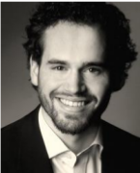
Hendrik Homölle is a Media Science graduate and has been working for MediaCompany as Project Manager for Live Communication since March 2014. He worked as Project Leader at Deutsche Welle (DW) previously. During this time, he designed the Deutsche Welle dialogue strategy and developed the social-media strategy. He successfully completed a trainee-program at the Zeitverlag in Hamburg and studied at the University of Cologne (Media Psychology and Media Management) and Stockholm University (International Politics and History of Art).
Astrid Ostrowicki - Art Director
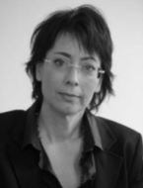
Astrid Ostrowicki is Creative Director at MediaCompany. Before coming to MediaCompany in 1999 this qualified graphic designer worked for two advertising agencies in Düsseldorf. Her core tasks include the development of corporate publishing projects and corporate design solutions.
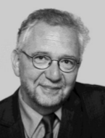
Holger Baum - Managing Director of MediaCompany / Strategic and conceptual consulting
Holger Baum is the founder of MediaCompany and its Joint Managing Director together with Stephanie Müller. This trained editor and certified business-economist gained his first journalistic experience at the newspaper. Later he moved to a medium-sized commercial enterprise as Head of Marketing before moving to the association 'Welthungerhilfe', where he gained his first overseas experience. As a freelance author he wrote for renowned daily and weekly newspapers and for some ARD radio stations. His work at the agency includes strategic, PA and communication consultancy. Various consultancy tasks for governments and international organisations led him to 15 countries in Asia and Africa.

References (Examples)
(Name, Number of participants, venue, year)
- National Closing Conference of the UN-Decade of Education for Sustainable Development, 500 participants, WCCB, 2014
- "5th International Conference of Ministers and Senior Officials Responsible for Physical Education and Sport (MINEPS V)", 600 participants, Intercontinental Hotel Berlin, 2013
- Outdoor Event of the Federal Ministry for Economic Cooperation and Development (BMZ): "Engagement fairbindet", 1800&3000 prticipants, Garden of the Chancellery BMZ, 2010&2012
- Conference: Sustainable North Rhine-Westphalia - Paving the Way for a Sustainable Future, 320 participants, Mercatorhalle Duisburg, 2012

Costs
The offer ofMediaCompany is quite fair, the costs for the all-together service including preparation, running the conference and many other services such as graphical work, consulting and and and are about 41.000 €.

Draft for the logo
There have been some ideas regarding the potential logo. On outcome is the following first draft, where the ribbon forms the river Rhine and in the background we see the seven mountains of the Siebengebirge.


