2. The hosting location

2.1 What city will the conference be in, what is interesting about it?

The location of the conference is the City of Bonn, maybe a little surprising, because everybody thinking of Germany is heading to Berlin... But Bonn as a smaller city (just more than 300,000 inhabitants) might be a more valuable place for a FOSS4G where people meet each other, and Bonn has a lot of things to offer, especially a Geoinformatics focal point, and a rich history!
Bonn is one of the oldest cities in Germany founded in the first century BC. Bonn is small - almost tiny, considering that it was Germany's capital for 50 years. At the same time it is very international due to its former status and lots of immigrants who came with embassies, foreign schools and businesses. This creates a very attractive conference location because it's easy to reach any point of interest in no time. Bonn is perfectly accessible due to 3 major international airports (details belwo) within an hour's train ride including the European hub Frankfurt (FRA). Bonn is also the heart of the European train network with 3 hours ride from Brussels (Head of the European Commission), 4 hours from London, and 5 hours from Paris.
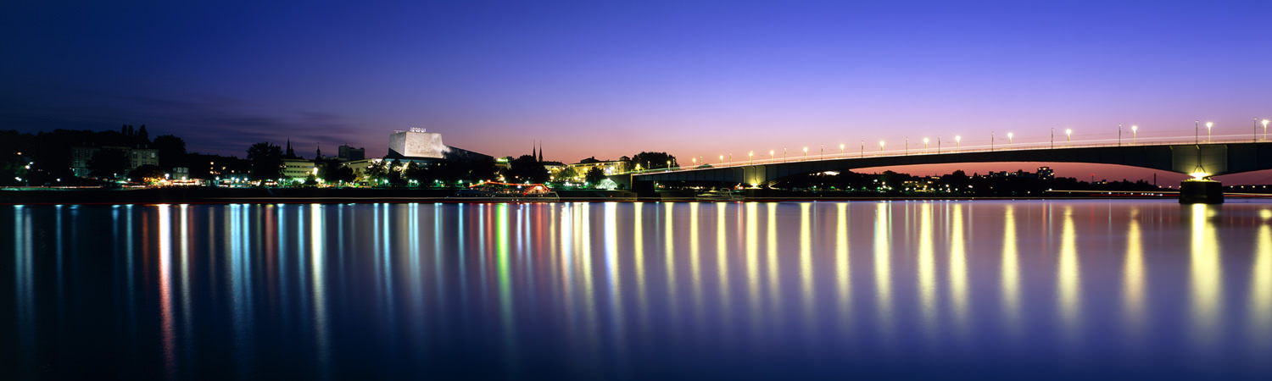City of Bonn by night, origin: website of city of Bonn www.bonn.de
Bonn is located at the Rhine River and the cities own slogan is ,,Freude", the German word for "Joy" and "Happiness". As the former capital of Germany Bonn kept it's spirit of an active, open-minded city. Over the past decade Bonn has managed to shape for itself a new profile as the German City of the United Nations and a center of the international dialogue on key issues of the future.

2.2 The Federal City

For nearly five decades, the city at the Rhine was known as the place where politics were made and where politicians changed the map of Europe in the early nineties. Although many politicians moved to Berlin since 1991, politics still is present.
Six out of the 15 Federal Ministries have still their first seat at the Rhine, and more than 20 federal authorities have moved to Bonn in order as compensation for the loss of ministerial jobs. Thus Bonn - with the title of Federal City adopted from a Swiss tradition - has become a second political focal point within the strong federal system of the German Republic.

On FOSS4G we want to keep touch to the political history of the city by using the former federal plenary chamber as our main conference hall.

2.3 Bonn International / the UN City

Since July 1996, Bonn is entitled to call itself a UN City. The Bonn UN Campus is a visible symbol of this development and is in direct neighborhood of the World Conference Center Bonn (WCCB), our conference venue.
Since 1991 a great number of organisations working in the international field have been attracted to the city. Together with about 150 non-governmental organisations they form a strong network. The most important success in the field of international activities, however, has been the settlement of currently 18 United Nations Organisations, amongst them the UN Climate Secretariat (UNFCCC). International activities concentrate on development cooperation, ecological topics and crisis prevention. Their common denominator is "UN in Bonn - working towards sustainable development worldwide".
Since 2006 the nucleus of the international Bonn is the United Nations Campus next to the World Conference Center Bonn to be enlarged according to UN requirements. The UN organisations have moved into the former office building of members of parliament. During the last years by organizing large congresses, Bonn has repeatedly proven its capacities as a convention city. Two World Climate Summits, the International Conference on Freshwater, the United Nations Talks on Afghanistan and the Conference of the Parties of the UN Convention on Biological Diversity are just some examples.
Since the relocation of the Deutsche Welle broadcasting corporation to Bonn in 2003, the international image of Bonn is also broadcasted world wide.

2.4 Bonn, a region for Science and Research

Embedded in the scientific triangle formed by the cities of Aachen, Bonn and Cologne, called the ABC-region and renowned as one of the the key regions of scientific research and technology in Europe, Bonn has acquired an international reputation as a scientific location. The nucleus is the university founded in 1818 with nowadays about 27 000 students. In addition, new institutes, research centers and universities of applied sciences have been created during the past years.
The scientific highlight is the CEASAR foundation (Center of Advanced European Studies and Research) focusing on interdisciplinary research on future oriented themes and the corresponding marketing strategies. Last but not least, Bonn hosts a series of leading German organisations fostering and promoting science.

2.5 Business

The services sector acquires a growing part within the economic system of Bonn, the trend shifting from public services towards private services. Major world wide operating companies have decided to establish their headquarters in Bonn, amongst them the Deutsche Post World Net and the Deutsche Telekom together with numerous subsidiaries. The IT sector alone lists about 800 IT companies which give employment to 25.000 people.
The whole region of Bonn has a strong focus in geoinformatics and beside numerous Open Source GIS companies, who all play a global role in the Open Source community is also home to several global players in the geoinformatics world, most of them are listed in our budget template.

2.6 Culture

Originally founded by the Romans, Bonn has a history of over 2000 years. Being the birthplace of Ludwig van Beethoven, music is an integral part of Bonn. The annual Beethoven Festival has become an important publicity event for the composers works. New museums along the Museum Mile attract a large number of visitors: the Art and Exhibition Hall of the Federal Republic of Germany, the Bonn Art Museum, the House of the History of the Federal Republic of Germany, the Museum Alexander Koenig and the technological German Museum Bonn welcome more than one million visitors every year.

2.7 Nightlife

Being a student dominated city, a lot of restaurants, coffee shops and restaurants are found within walking distance from the city center. Bonn nightlife is thriving and fun-filled. Whether you want to eat, drink, party and dance all night, or sit under the stars with a local brew in hand, Bonn is the city that suits all your needs in this German city of nightlife.

2.8 Some Quick Numbers

Bonn today is a city with over 318.000 inhabitants, ranking Bonn in 19th place of German cities. Bonn has always been a world open and multi-cultural city, today this is expressed by many groups of migrants from Turkey, Poland, Morocco and other countries.

The University with the main building, the former castle of Prince Clemens August is home of about 27.000 students, which keep the face of the city young and living. Hotel business registers more than one million overnight stays per year. The unemployment rate around 7 percent is situated clearly below the national average.
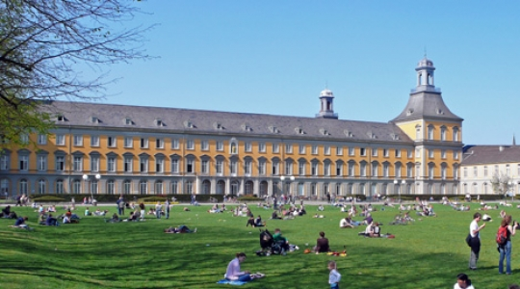University Bonn, origin: website of the City of Bonn www.bonn.de
University Bonn, origin: website of the City of Bonn www.bonn.de

2.9 Bonn – the Region

Bonn is said to be “The Gate to the Romantic Rhine”, because it is located directly where the Lower Rhine Valley opens from the Mittelrheintal, an UNESCO world heritage site.
A few kilometers to the south the oldest german nature reserve, the Siebengebirge, is located. This mountainous area also is the main shape of our draft logo. Attendees can discover this former volcanic area, which is crowned by medieval fortresses by boat or hiking. A bit to the south is the Ahrtal, which is also called „the wildest daughter of the Rhine“. That's not surprising given the scenery, with the romantic course of the river, wonderful rock formations, ruins, idyllic castles and picturesque terraced vineyards.
Just a half hour north of Bonn you can reach Cologne with its world famous Gothic Cathedral, the Kölner Dom.

2.10 Accessibility

With three international airports Frankfurt (FRA), Cologne-Bonn (CGN) and Düsseldorf (DUS) within an hour train distance and direct connection to the major north-south bound railway network Bonn is excellently accessible for guests from Germany, Europe and all over the world.

→ Cologne/Bonn Airport
www.koeln-bonn-airport.de
Konrad Adenauer Cologne-Bonn International Airport (CGN) is only 22 km or 20 minutes by car or bus from downtown Bonn. The airport is easily accessible by bus shuttle and taxi.

→ Düsseldorf Airport
www.duesseldorf-international.de
Düsseldorf International (DUS) currently serves 180 destinations worldwide, including 8 Eastern European countries with 21 destinations. Bonn is also directly linked to DUS via the Deutsche Bahn railway system.

→ Frankfurt Airport
www.airportcity-frankfurt.com
Germany’s largest airport (FRA), enjoys direct service from all over the world. Bonn is also easily reachable from the airport FRA via the ICE train (travel time of 50 minutes directly from the airport Distance from Bonn to Frankfurt Airport: 150 km.
→ Bonn and Siegburg/Bonn ICE Train Stations
www.deutsche-bahn.de
The Bonn region is ideally linked to the European railway system via the Bonn and Siegburg/Bonn railway stations. The Frankfurt and Düsseldorf Airports (FRA and DUS) are both quickly accessible by rail in just 50 minutes. Travel time to Bonn’s neighboring city of Cologne is only 20 minutes.
→ Public Transport
www.stadtwerke-bonn.de
The city boasts a dense public transport network, offering conference guests quick transfer options. Bonn is a city of short distances: whether on foot or by subway, street car, bus or taxi, every destination is just minutes away.
→ Highways
www.autobahn.nrw.de
Bonn is linked to the European long-distance road network via the local highway system, allowing for easy access by bus or car from both within and outside the country. The Bonn region’s excellent transportation infrastructure provides conference guests with a quality travel experience and ensures fast transfer times.

2.11 What venue will the conference be in, what are the number of rooms available, seating, and associated pricing?

The conference will take place in the World Conference Center Bonn (WCCB). It is located in the middle of Bonn’s former government district, in the immediate vicinity of the United Nations Campus, Deutsche Post DHL headquarters, Germany's international broadcaster Deutsche Welle, and next to the river Rhine.
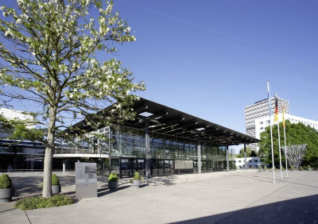WCCB - World Conference Center Bonn, origin: WCCB_website: www.worldccbonn.com
The convention center is a very unique facility – only here conferences and events can be held, where parliamentarians once debated and changed the shape of a whole continent.
On the next pages we will introduce to the venue with it's official words....

2.12 The Worlds Conference Center Bonn (WCCB)

The conference venue is located slightly south to the city center. Early birds may reach the venue by foot (about 2 km from Bonn's city center) or by tramway or bus.
The World Conference Center Bonn is located in the middle of Bonn’s former government quarter, in the immediate vicinity of the United Nations Campus, Deutsche Post DHL, the international media broadcaster Deutsche Welle, international organizations, and next to the river Rhine. The convention center is a very unique facility – only here can conferences and events be held, where German parliamentarians once debated. The World Conference Center Bonn is equally suitable for conferences and conventions, exclusive product launches or atmospheric evening events.
A nice place to meet in breaks or directly after the conference is the new built „SKY BAR“ (see GeoBeers) on top of the new Hotel building with a wonderful view to the Siebengebirge, the Rhine and the city. This is the place where „After Conference“ socializing starts before enjoying the evening programme.

2.13 The plenary chamber – or – the former German Parliament

The conference center will we the so called plenary chamber. That is the place where the German Parliament met from 1992 until 1999. The former parliament chamber, where Europeans frontiers changed and the parliament voted for Germany re-union, the „Wasserwerk“ is just a few meters away. But back to the plenary chamber, we cite from WCCB's website: „The glass and steel building lies at the heart of the former government quarter in direct proximity to the Rhine.“
The central part of the conference is the plenary chamber. Former conferences „come together halls“ alsways have been inside – no daylight. With the transparent effect created by the glass construction, and its harmonious integration into the cityscape, the Plenary Chamber is considered to be one of the most beautiful plenary buildings in the world. It has capacity for 1,230 persons to meet.
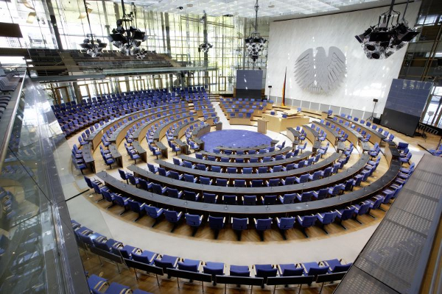The plenary chamber ... waits for FOSS4G WCCB Bonn, origin: WCCB_website: www.worldccbonn.com
Its entrance lies through the spacious Bundeshaus lobby. The glass walls and light steel construction create a lively atmosphere suffused by light, symbolizing democracy and political transparency. The large glass walls erected behind the chamber allow a direct view of the Rhine and the opposite bank.
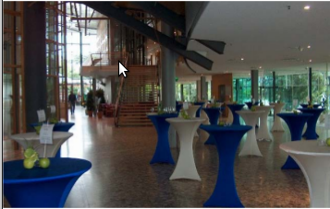The Rheinlobby (exhibition and catering), origin: WCCB_website: www.worldccbonn.com
Covering a floor area of 30,600 sq. m., the various rooms in the building provide facilities for various events. Whether shareholders’ meetings, receptions, congresses and conferences, gala dinners, or exclusive product presentations, the Bundeshaus provides a unique location.

2.14 The local team and WCCB – with our own words

When we decided that FOSSGIS e.V. wanted to put in a bid for FOSS4G 2016 it was just a little idea, a dream.
That this dream should take place in Bonn was clear relatively early, since the three FOSS4G related, internationally known Open source companies WhereGroup, lat/lon and terrestris are located here. Thus the World Conference Center Bonn with the plenary chamber was an obvious choice for hosting the conference. After viewing the conference center, we are certain that this is the location where OSGeo should celebrate the 10th anniversary of the FOSS4G conferences.

The center of the conference is the light plenary chamber with its outstanding atmosphere. The WCBB is the only place world wide where you can have a symposium in a former parliamentary plenary hall. Is there any better accolade for our fantastic software, than presenting it at a place where you can still feel a breeze of history while contributing to an open future of software, data, and standards?
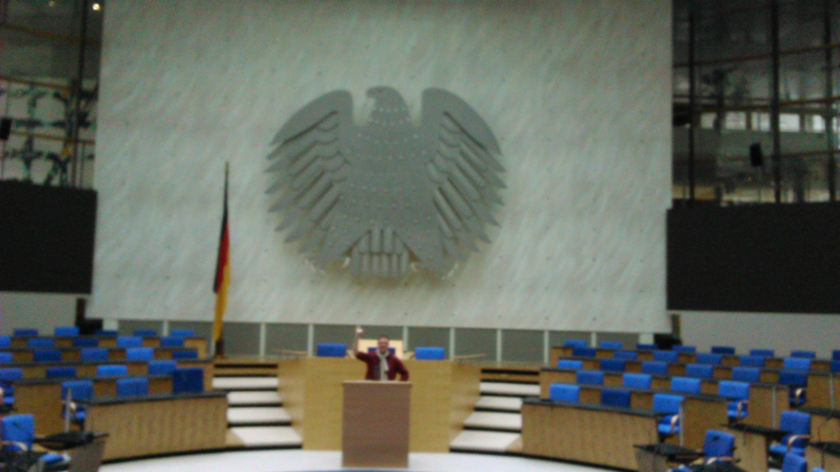WCCB - plenary Chamber with Marc Jansen, origin: Till Adams
Additionally it's beautifully located directly at the Rhine and makes short breaks or even a longer walk through the scenic „Rheinauenpark“ along the Rhine possible.

The WCCB offers enough smaller and larger sized rooms for sessions (see below). There's also great flexibility in choosing the rooms according to the program, as the final decision needs to be made only a few weeks before the conference, and not on the initial booking.
There's also enough room around the plenary chamber for the exhibition, catering, seating, power supply and add-hoc meetings. In addition there's an outdoor area for the breaks where seats can be provided by the caterer breaks and relaxing. Inside there are two rondels that can be used for a comeback of the FOSS4G demo-theatres.
Around the plenary chamber there is also lot of space for exhibition, catering, socket stations and also space to meet and relax..

2.15 Technique

When visiting WCCB we had an extra meeting with staff members of the technical team of WCCB. In advance, we've sent a list of requirements on the WLAN, LAN and phone technology, based on the experiences of past events. The core-facts of this list were as follows:

- up to 10,000 concurrent accesses to WLAN (1000 visitors, up to 4 devices in changing positions) with sufficient IP-adresses;
- Avoiding of web-based access-sites because this always caused problems on past events and also we know, that a lot of visitors will work on the command line directly;
- many of the visitors want to download huge data packages, as announcement of new versions (i.e. QGIS 2.0 in Nottingham), which means a download of at least 1.5 GB per visitor per day;
- On past events all log-systems, firewallls, redirects and complicated proxies etc. always caused problems.
- No ports should be blocked (FTP, SSH, IRC, etc.)

There was nothing the technicians really alienated. In the course of the opening of the new building the complete LAN/WLAN technology now is up-to-date. The connection goes over a 100Mbit line with a active/passive 34 Mbit backup line, which could be extended.
Normally they use a voucher-system, but for our responsibility they see no problems in switching this off and open the full WLAN for free access.
If we keep the voucher-system in use, they offer a pre/postload-site, which could be addressed to a WLAN-sponsoring site. So there is the possibility to gather a WLAN-sponsor who might take over some of the costs for technique.
Parallel to the WLAN net there is a LTE/Mimo-based inhouse mobile radio communication unit. So all traffic, that runs over GXM/UMTS will not put extra load on the WLAN.
In the exhibition area they can deliver LAN-access for exhibitors.
In general the technical guys are very familiar with high requirements as they often run UN-conferences where many people work together with WLAN during the conference. There will be a technical team on-site during all conference days.

2.16 Rented Rooms

- Plenary Chamber 1230 Seats, 2 Video Walls
- Room Bonn 1,2,3 181 Seats total, could be divided into three single rooms
- Room Berlin 1,2 121 Seats, could be divided into two single rooms
- Room Bangkok (New Building) 350 Seats, could be divided into two single rooms
- Room Addis Abeba 1 130 Seats
- Room Addis Abeba 2 130 Seats
- Room Addis Abeba 3 130 Seats
- Press Balconee
- Presidential Area 1.5 20 Seats
- Presidential Area 1.7 20 Seats
- Presidential Area 1.10 20 Seats
- Presidential Area 2.5 20 Seats
- Presidential Area 2.7 20 Seats

All rooms have LCD projector, screen, flip-chart, speakers desk and sound system. Recording of presentations is also possible. A technician will be available during all sessions.
The presidential area will be used as conference office, rooms for uploading presentations and for preparation for speakers. One of them could also be used as „open program room“ for ad hoc presentations or other events.
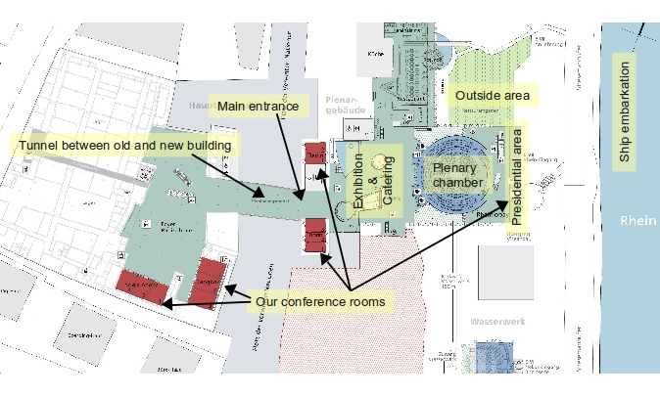Floorplan of the WCCB, origin: derived from floorplan of WCCB
N
For a bigger floorplan see Appendix V.

2.17 Available workshop facilities, number of rooms, computers per room, pricing, strategy for providing workshop facilities.

There are plans to let the workshops happen in rooms of the University or to get a sponsoring in form of free workshop facilities in rooms of Deutsche Telekom, the biggest German telecommunications provider. As this is not fixed yet we have to calculate with the most expensive alternative, to let the workshops happen in rooms of the WCCB.
We inquired for 10 workshop rooms inside WCCB, which would allow us to let 40 workshops happen (see preliminary program sheet). All rooms are equipped with 20 PC's each, LCD projector, presentation computer, flip chart and other regular equipments.

So if 2 persons share one computer, 40 participants per workshop are possible. In our calculation we calculate with 20 participants per workshop.

2.18 Available rooms for additional small business meetings

As said above, there are several additional rooms in the WCCB we plan to rent. These are the named rooms in the presidential area. They give room for additional small business meetings beside the exhibition and generous allocated space around the plenary chamber.

2.19 What is the maximum size your venue could entertain? The minimum?

The plenary chamber gives room for 1230 people. As we plan the plenary chamber as the central come together room for FOSS4G in Bonn this is the maximum size we can provide.
If for any reasons early bird registrations will be far above what we expected, there is the possibility to move into what is called the new building of the WCCB which gives room for up to 4500 visitors.
The break-even point is 630 participants. The interior of the plenary chamber gives room for about 650 people (the rest is above the plenary area), so the minimum number will be somewhere at 650 visitors.

2.20 Accommodation in Bonn

What accommodations are available? Where are they relative to the venue? Pricing? Quantity?
Bonn has a wide selection of outstanding hotels in all categories. The World Conference Center Bonn is perfectly located within walking distance of the major hotels in the city. Within a short distance you find the largest hotels in Bonn. In addition to this a new hotel directly connected to the new conference complex is under construction and will be opened in 2015. The World Conference Center-Hotel will offer 330 rooms and suites.
All the accommodation management and hotel booking is a service from BonnHotels, the local hotel booking system for the region of Bonn run by Bonn Tourismus and Congress GmbH (T&C). It will be ensured that BonnHotels (http://BonnHotels.de) will allocate the required number of rooms for FOSS4G and it will be possible to book the hotel room allocation by phone, fax, e-mail and the Internet. There will be a direct link from the registration site to the hotel booking service.

BonnHotels conference-related services comprise:
- Arrangement of a hotel room allocation for the self-booking service made available through a hotel link. Implementation of the room allocation into the online booking site.
- Preparation of one standard booking link incl. logo implementation, to be published on the conference website and/or in any notes for participants.
- Consulting service and assistance for participants during their booking procedure by phone, fax or e-mail
- Automatic e-mail confirmation of a booking to the participant and the hotel
- Participants will pay for the accommodation at the hotel
- All hotels associated with BonnHotels.de have only favourable price offers.
- The same room package will not be offered in any other hotel reservation system for a cheaper price.
- All the bookings placed through BonnHotels.de will include a free public transport ticket valid for the duration of your hotel stay.
- The public transport ticket will be sent out as a PDF document together with the booking confirmation itself.
- The ticket is valid for traveling throughout the Bonn-Cologne Region on all public transport including the bus transfers from and to Cologne /Bonn airport.
- Last but not least, all the above listed service is free for visitors and the conference organisator.

