3. The hosting organization and local community.
In the following we list supporting local organizations (companies, universities, user groups) and individuals that are involved in the local conference committee. In the following we will introduce FOSSGIS e.V. as local OSGeo chapter and the heads the LOC consists of.
- FOSSGIS e.V.
- City of Bonn
- Geobusiness Region Bonn
- Open Geospatial Consortium (OGC)
- UN Spider, Office for Outer Space Affairs
- University of Bonn, Department of Geography
- University of Bonn, Department of Cartography
- University of Applied Sciences
- Local businesses (terrestris, lat/lon, Wheregroup and others)

FOSSGIS e.V.
The FOSSGIS e.V. (a german "Verein", and therefore a legal non-profit entity comparable to a member association) is the german speaking chapter of OSGeo for the so-called D-A-CH-Raum including Germany, Austria and the German speaking parts of Switzerland. FOSSGIS currently is supported by almost 200 paying associated members. The main focus of the FOSSGIS association is to advance and spread Free and Open Source Software in GIS, support the growth of free and open data and promote the use of open standards. The precursor of the FOSSGIS is the GRASS Anwendervereinigung which was founded in 2001 actually predating OSGeo and even FOSS4G by a few years. :-)
Additionally to most other OSGeo local chapters, FOSSGIS has a strong focal point on the german speaking OpenStreetMap community acting as the legal entity for OSM in Germany in many cases.
Our main yearly event is the FOSSGIS conference. It started as a „German speaking UMN MapServer user conference“ in 2003. Events in the past years saw at least 400 attendees, last year in Berlin we reached 560. Although only in German language FOSSGIS nowadays also attracts visitors from other local OSGeo folks, especially from our adjacent countries, e.g. members of the Dutch, Belgian, Czech, Italian and Danish local chapters.
FOSSGIS e.V. directly supports OpenSource communities by sponsoring Code Sprints and runs events focusing on connecting communities and development groups. Every year FOSSGIS organizes a hacking weekend to further the goals of the association.

Local organizing committee.
We have the confirmation to support FOSS4G 2016 in the event that it comes to Bonn in Germany from a lot of active members from a broad range of organizations including business, government, universities and research institutes. For this proposal we will present the people being active in the proposal-process more in detail:

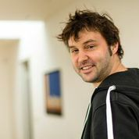
Till Adams - Our conference chair. Till is one of the founders of the local FOSSGIS conference and joined his first FOSS4G in Minneapolis in 2005, when the conference name even wasn't FOSS4G. Till put a lot of effort into local and regional community building, especially in for the FOSSGIS local chapter, where he is member of the managing board.
In his main job he is founder and managing director of terrestris, an Open Source GIS company involved in especially webbased FOSS4G software-development. Till is actively working with FOSS4G Software for more than 10 years.

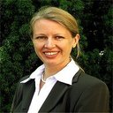
Athina Thrakas - Athina Trakas is Director for European Services at the Open Geospatial Consortium (OGC). In her position she is the contact person for OGC in Europe, responsible for the OGC’s activities and networking in Europe.
This includes raising awareness of OGC standards by technology providers and users, connecting with European stakeholder organisations, the European Commission and members, supporting regional and national forum activities and planning and managing of OGC outreach and recruitment. Athina also has a strong focus on the OpenSource community and in her role, she acts as our connection to OGC.


Arnulf Christl - Arnulf Christl is Geospatial Systems Architect and director of metaspatial. He works globally as consultant, innovator, prototyper and project manager for a range of clients. He frequently appears at conferences, workshops and seminars. Arnulf has been founder and president of the OSGeo foundation for many years. We think, there is nothing more to say about the work of Arnulf in the international FOSS4G-community.

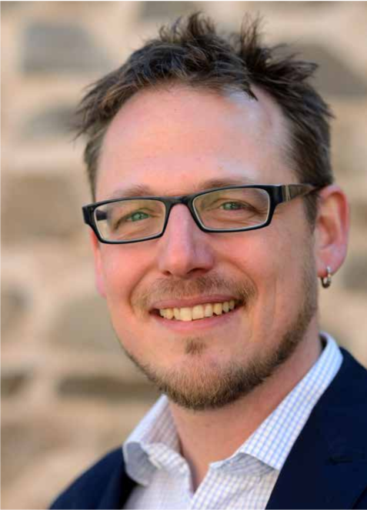
Dr. Marco Lechner - Marco is the president of FOSSGIS e.V., the german speaking local chapter of the OSGeo and manages his eighth FOSSGIS conference this year.
Marco will take care about all kinds of issues in the LOC and especially for all issues, where FOSSGIS-people get involved.
In his main job Marco is project manager and developer of geospatial projects and processes in an Open Source company. He's a professional lecturer for many OSGeo software projects. In his second live he is an political activist for Open Data and Open Strategies in general.

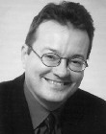
Prof. Dr. Klaus Greve - Klaus is Professor at the University of Bonn in the Deptartment of Geography. Klaus is working with Geospatial Software since many years and also was Co-Founder of lat/lon. He is our connection to the EARSEL organization and also to the University of Bonn. Klaus will be the main organiser of EARSEL conference.
We also plan at least to host the code sprint in rooms of the University, so there is a strong need to have direct link to University as well.

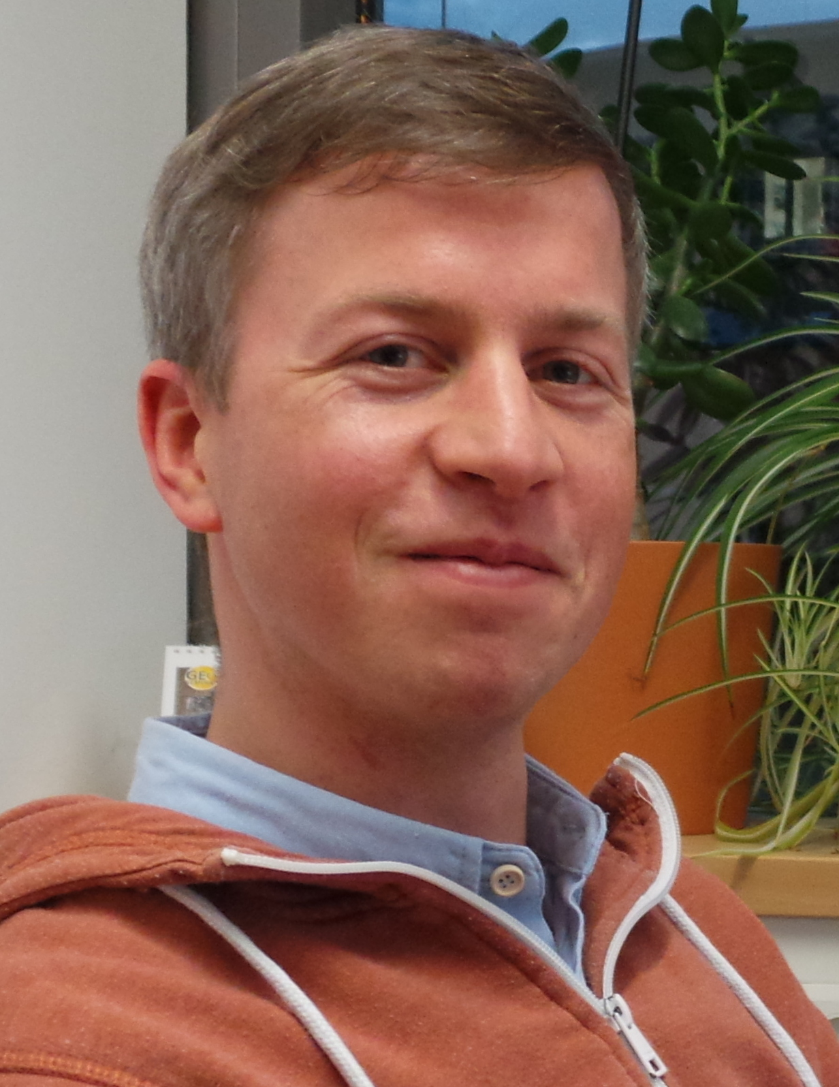
Christian Willmes - Christian is PhD student in Geography/GIScience and Research Assistant at the GIS & RS Group of the Intitute of Geography at the University of Cologne. He studied Geography, Computer Science and Cartography at the Universities of Cologne and Bonn. He applies and advocates Open Source GIS technology in research and teaching. Since an intership at WhereGroup in 2007 he is involved with FOSSGIS and OSGeo, and is a regular attendee and speaker at FOSSGIS and FOSS4G conferences.
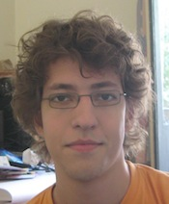
Volker Mische - Volker is a developer and came in touch with the OSGeo in 2008 in Australia. Since then he attended all global FOSS4G conferences. As a proponent of open source, he has contributed to various projects, such as OpenLayers, GeoNetwork, CouchDB and his own project GeoCouch.
Volker has good experience in contributing to the FOSS4G programm committee (2009 and 2014) and will support the LOC in this field.

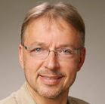
Prof. Dr. Franz-Josef Behr – Franz-Josef is Professor of spatial information processing at Stuttgart University of Applied Sciences. Franz-Josef is also Member of the DIN working group, Co-founder of Applied Geoinformatics for Society and Environment and FOSS4G Southeast Asia 2012 and Head of the HFT ICA-OSGeo Lab. He also was Co-chair of the Academic Track of the FOSS4G's 2013 and 2014. He also is reviewer for ISPRS Journal of Photogrammetry and Remote Sensing, the International Journal of Geographical Information Science, Transactions in GIS, Natural Hazards and Adjunct Faculty at IIITM-K, Trivandrum, India. Franz-Josef will be the chair of the academic track of FOSS4G 2016.

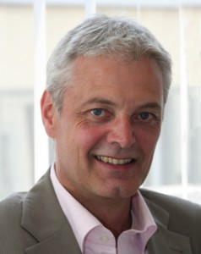
Dr. Ulrich Ziegenhagen – Ulrich is Deputy Director of the Office of Economic Development of the City of Bonn and in this function the cluster managemer for the Geoinitiative Bonn / Rhein -Sieg / Ahrweiler. He also is chair of the entrepreneurial initiative Geobusiness Region Bonn.
From his position we integrate Ulrich especially for gathering sponsoring from local companies. Ulrich is also our connector to all activities which have the necessity to be co-ordinated with the City of Bonn.

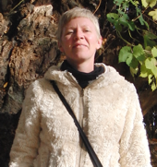
Katja Haferkorn - Katja is geographer, networker and member of FOSSGIS e.V. She has been coordinating FOSSGIS-conferences in detail since years and is responsible for the FOSSGIS conference becoming more preofesional year by year.. She will look after the Conference bags, T-Shirts, Artworks, Catering and Public Relation simply all things she does well on FOSSGIS-Conference. She has good contacts with potentially sponsors and many participants of FOSSGIS-Scene.

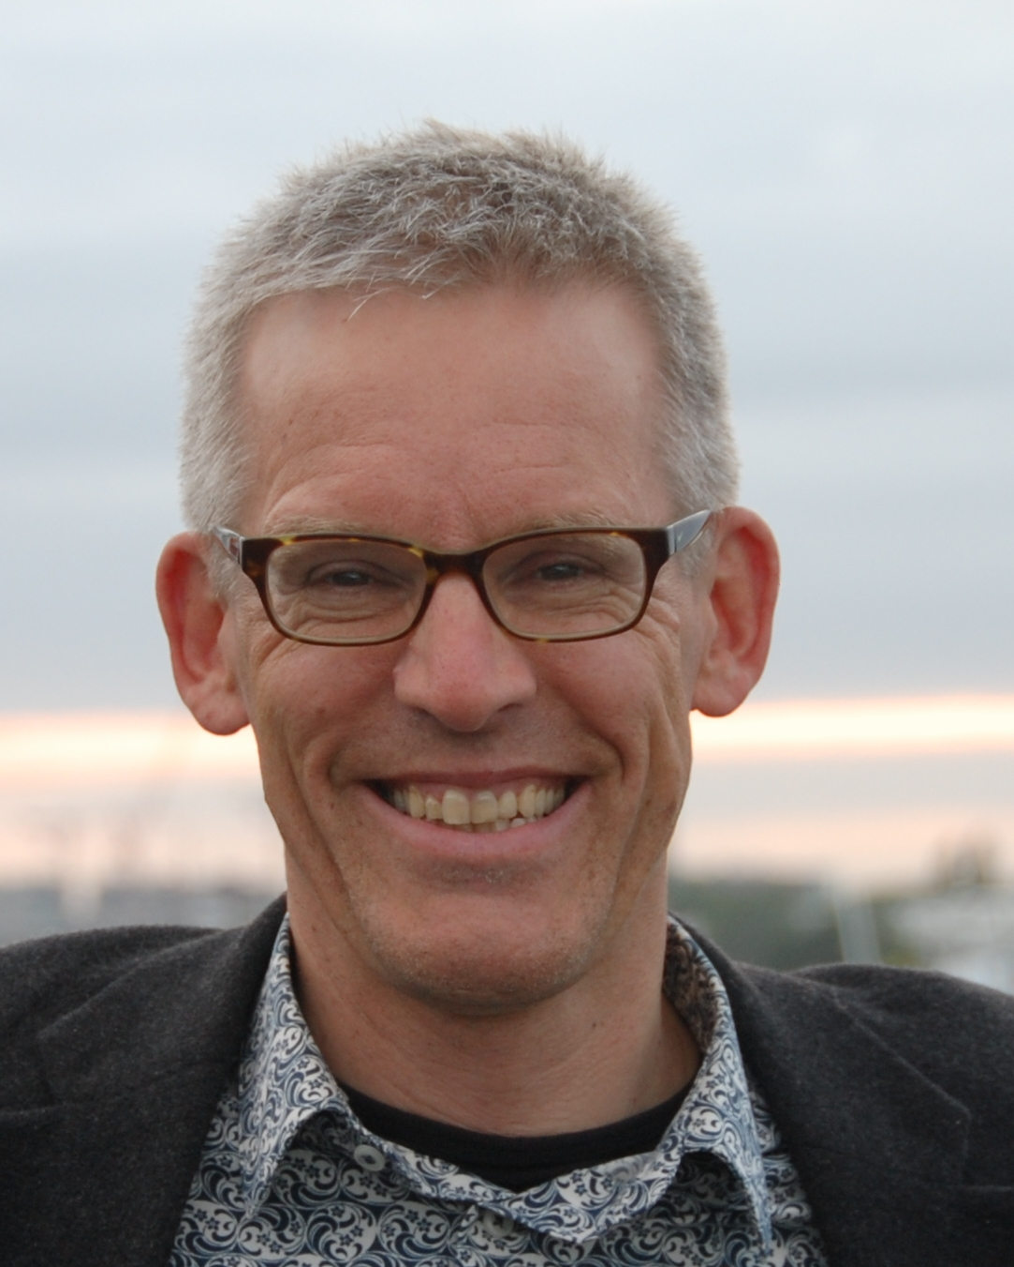
Gert-Jan van der Weijden - Gert-Jan is since 2013 president of the Dutch local Chapter "OSGeo.nl". In this role, he was heavily involved in the organisation of the yearly Dutch "OSgeo.nl" day. His main goal to broaden the outreach of Open Source Geospatial, Open Data and OpenStreetMap. Therefore, his contacts, articles and appearances reach not only into the Open Source community, but also in the less-open parts of "Planet Geospatial".
For a FOSS4G 2016 his main task will be to act as a "linking pin" between the German-based organization and the Dutch-speaking community, thus promoting the cross-border nature of FOSS4G.

Antje Hecheltjen – Antje works as a GIS-Specialist for UN SPIDER Organisation and thus focuesses her interest on natural desaster management and Geospatial Software and Data. In her role and her organisation in general is interested in Open Source software and Open Data as well.
For the LOC Antje will be our contact person to UN-Campus in Bonn and will be part of the local program commitee.

Local open source development and implementation activity, interest and enthusiasm for open source geospatial in your region.
Maybe there is some wonder, that we've choosen Bonn and not Berlin as our conference city. But beside the phantastic venue there are more facts, that let us favour Bonn as FOSS4G cxity.
Bonn is something like the core area of Open Source Geospatial Business in Germany. So it's not a surprise that three companies from Bonn actively support incubated OSGeo projects – lat/lon (deegree), Wheregroup (Mapbender) and terrestris (contributing actively to OpenLayers and other OpenSource projects).
In Bonn, also called the Silicon Valley of geoinformatics all well nkown Geospatial Companies have their office. We plan at least to involve all these companies as trying to gain them as sponsors. This will also give the chance for a deeper understanding between the proprietary and Open Source geospatial world.
All local companies and also some regional public administrations working in the field of geoinformatics are organized in the entrepreneurial initiative “Geobusiness Region Bonn“ (http://www.geobusiness-region.de/). Geoinformation and region Bonn are a brand that is capable to gather further expertise and capital to attract one growth-oriented and young industry.
Other activities are supported by FOSSGIS e.V. with sponsored Code Sprints (yearly the Bolsena Code Sprint, GeoExt Codesprint 2013 in Bonn, the Vienna Code Sprint 2014, OSGeo Code Sprint Philadelphia 2015, e.g.), annual hacking weekends and also by supporting projects. Every person or organisation may apply for sponsoring at FOSSGIS e.V. for projects dealing with Free and openSource software.

How do you plan to manage/organize work and relations with OSGeo (especially with the board and conference committees)?
Members of the Local Organizing Committee have served on the OSGeo conference committee in earlier years, have been on the OSGeo board of directors and also drafted considerable parts of previous FOSS4G events.
The conference will be managed following a clearly laid out plan and the LOC chair will inform the OSGeo board of directors and conference committee on a monthly basis. It is not expected that there will be a lot of help coming from OSGeo but major decisions and especially changes in plans will be communicated immediately so that OSGeo can take a position.

